**MA 374 - Financial Engineering Lab06**

**Sahil Kumar Gupta**

**200123081**

Note: As there are many plots in this lab assignment and it is instructed that we need not put all the plots, I have shown only some plots and relevant ones.

**Q1**

Plot of stock prices against time

* **bsedata1** plots (price vs time)

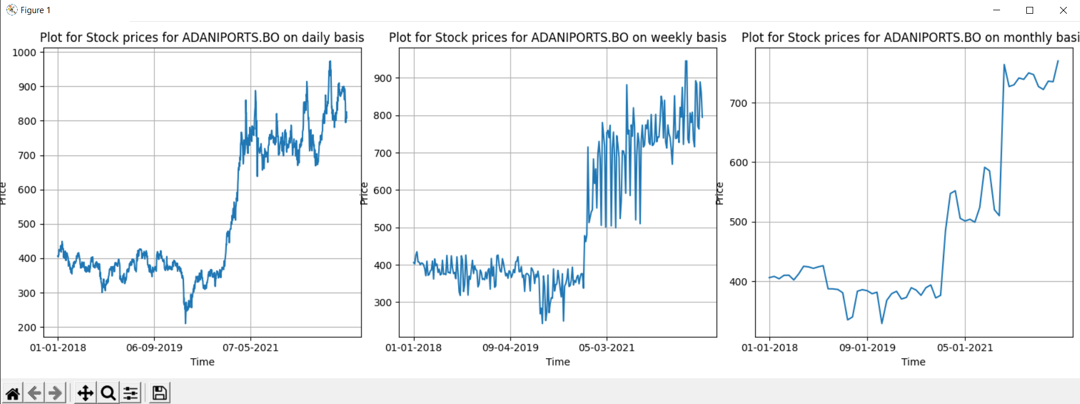

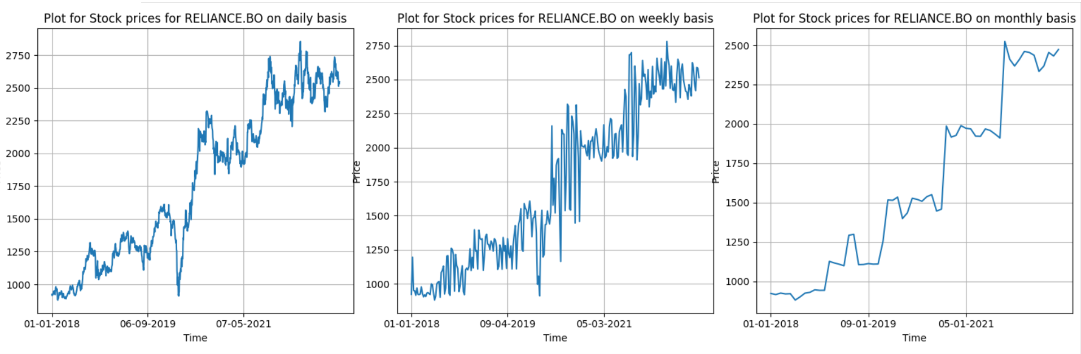 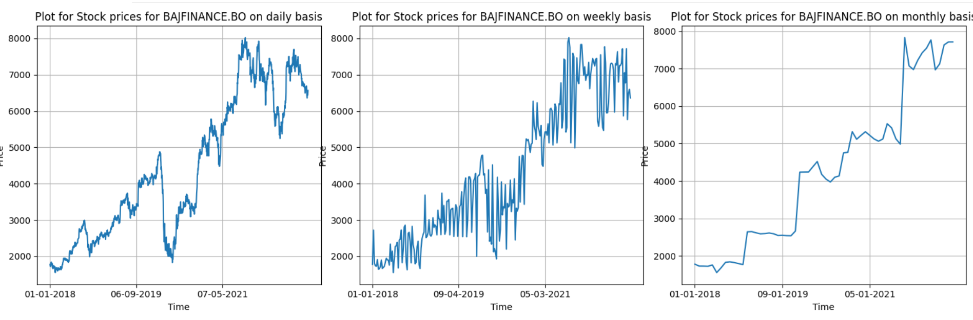 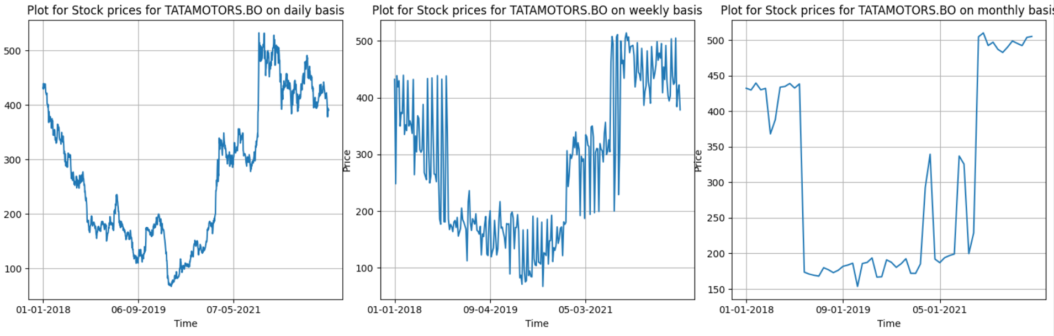 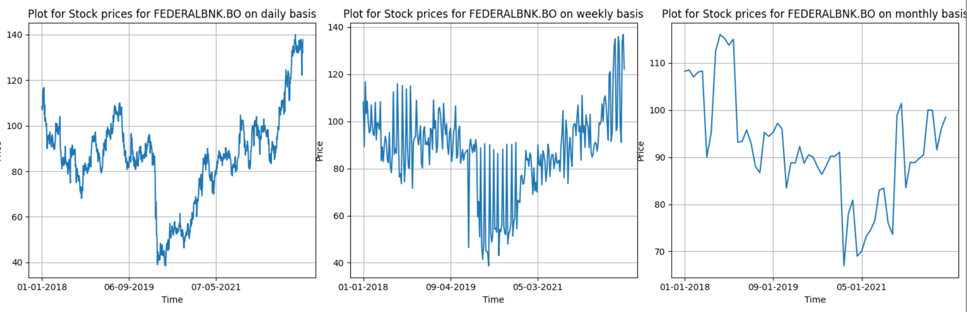 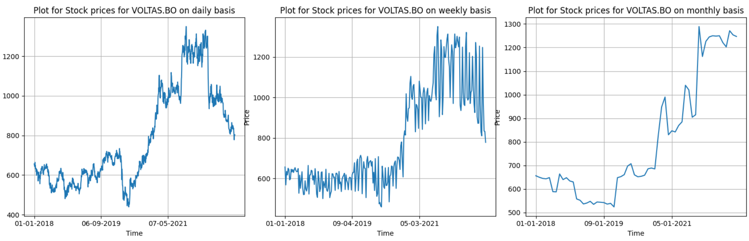 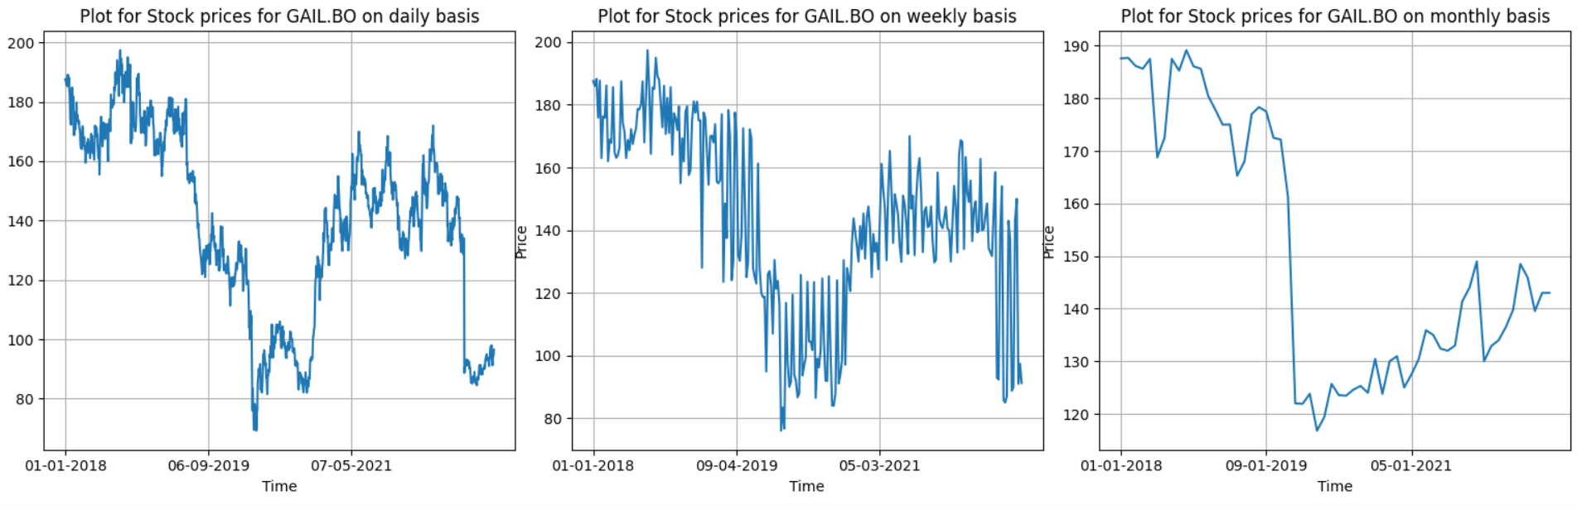 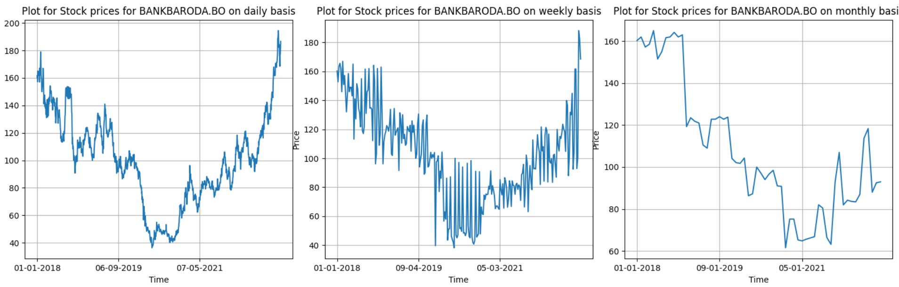

* **nsedata1** plots (price vs time)

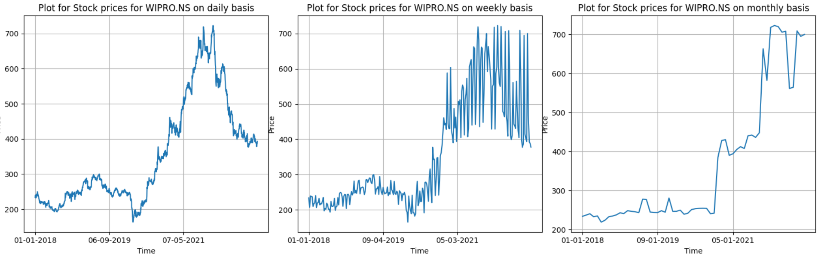 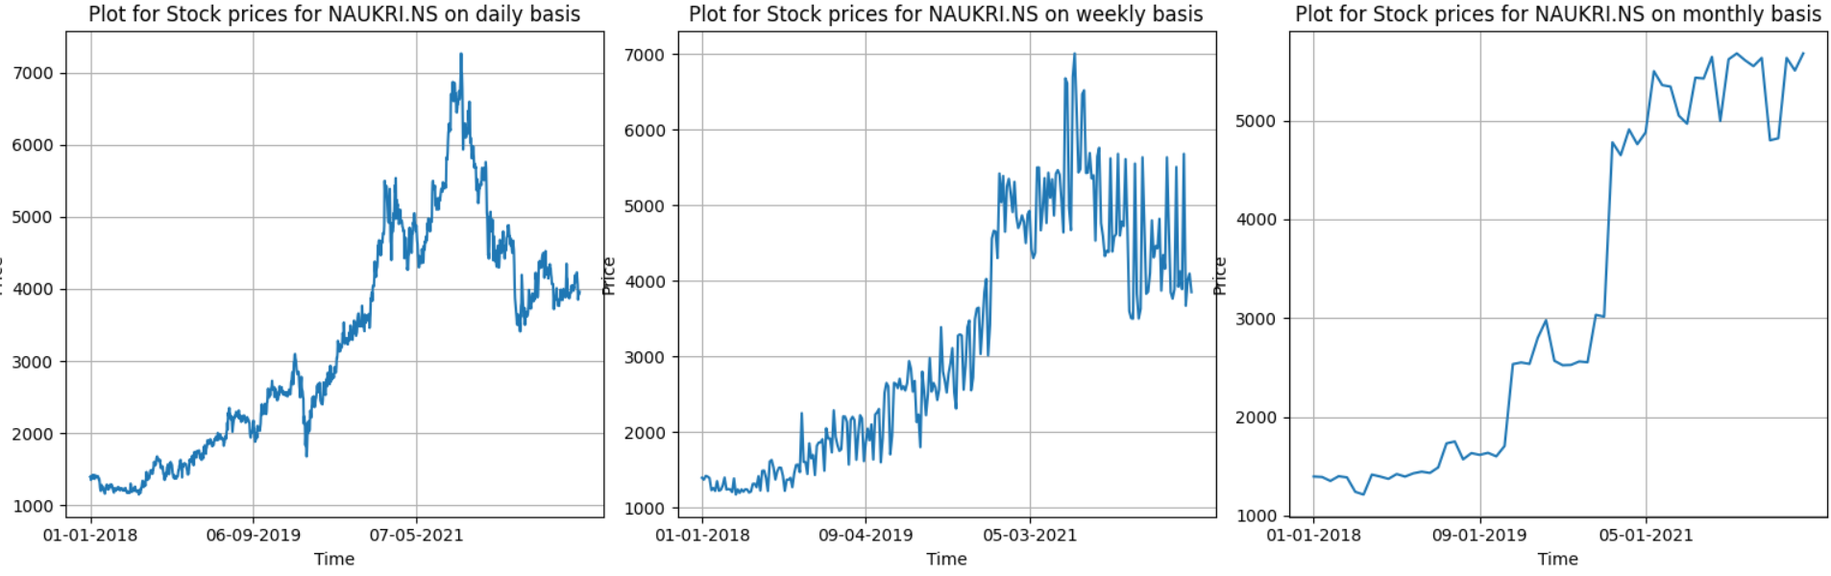 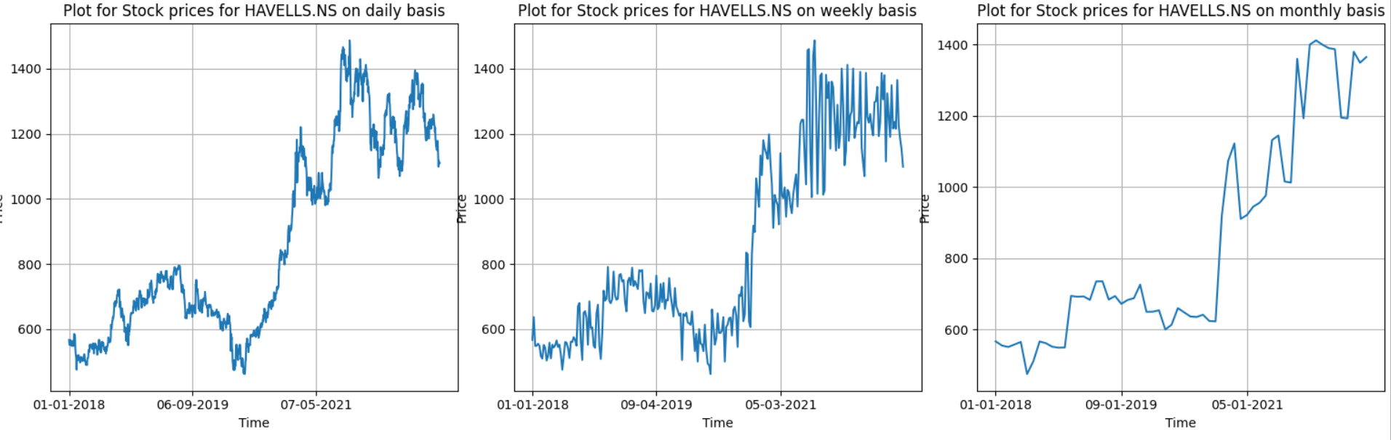 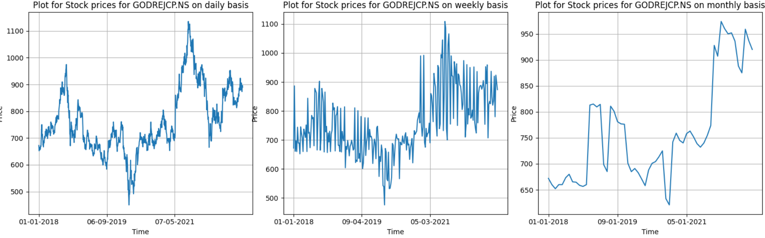 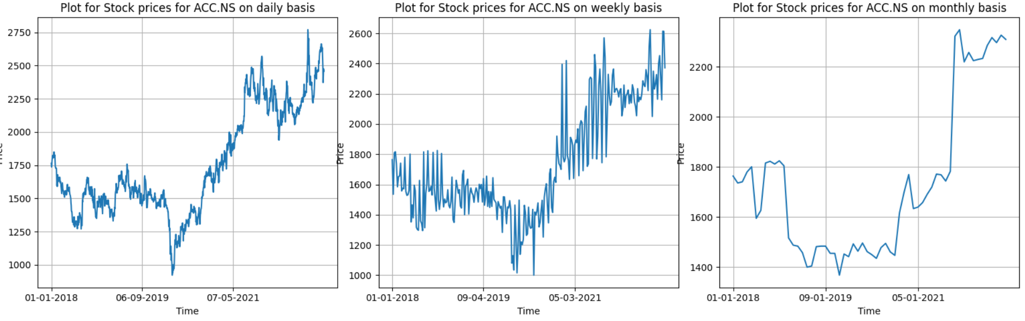 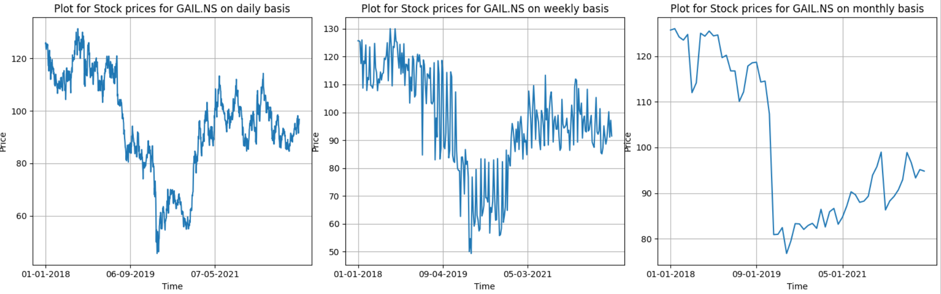

**Q2**

**BSE DATA ANALYSIS**

* Plots (not all) for returns (Ri) for **bsedata1** are:

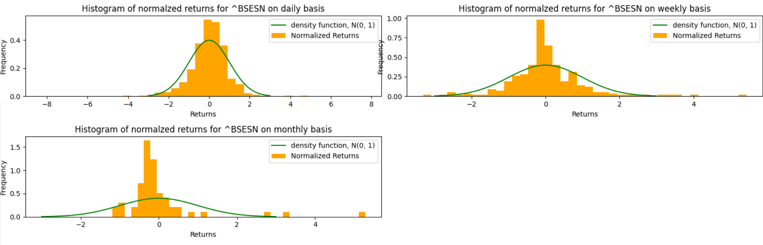 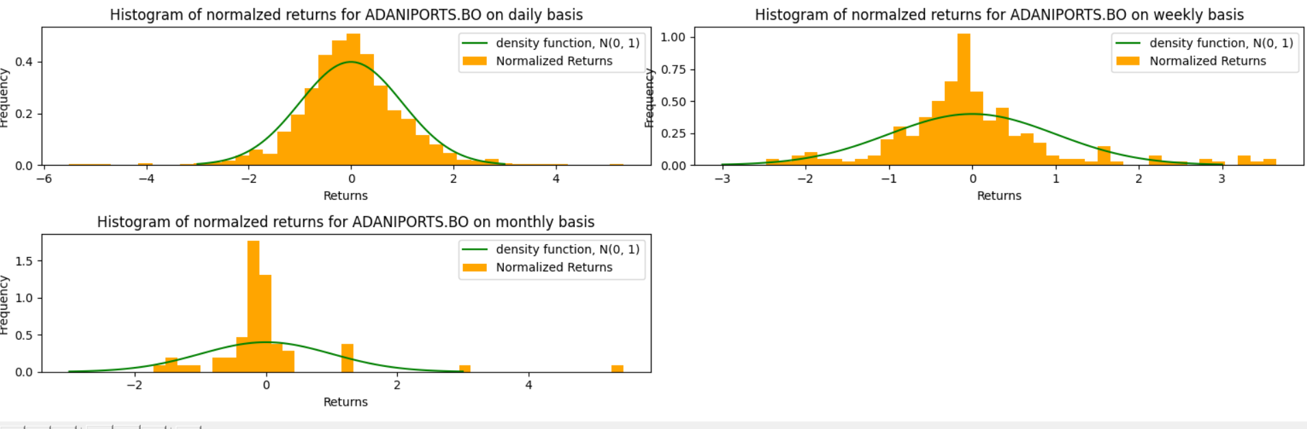 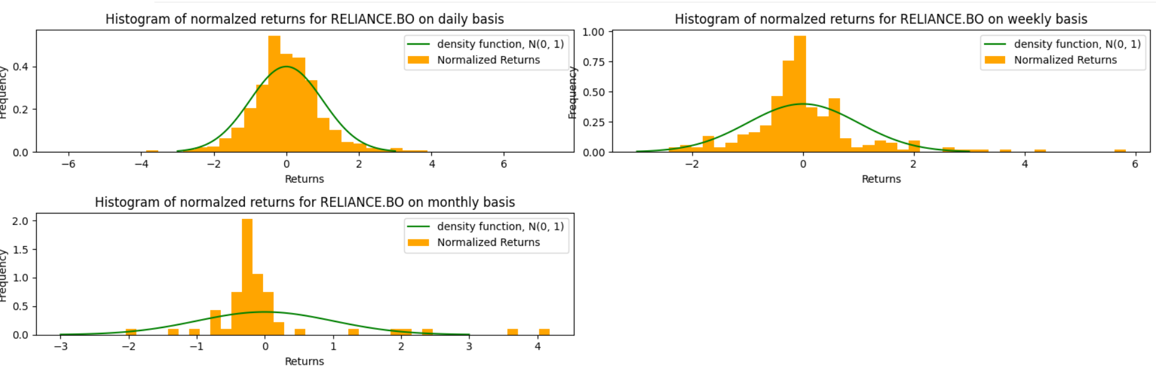 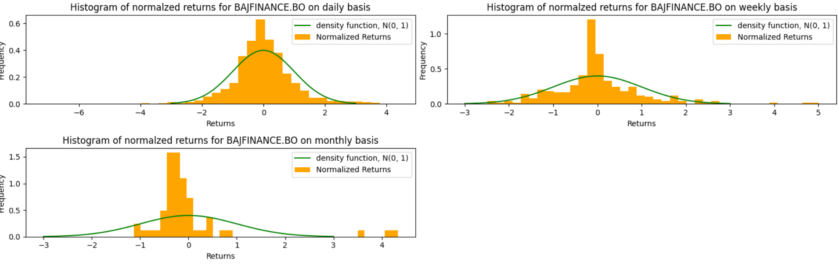 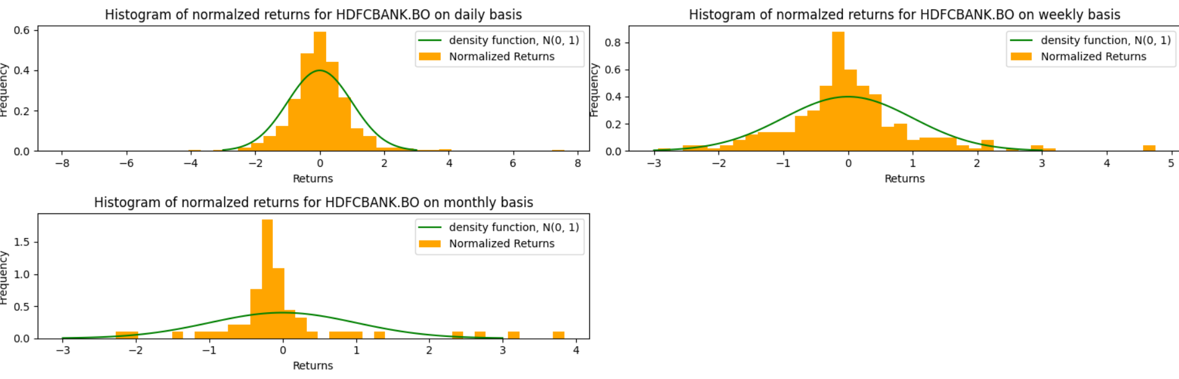 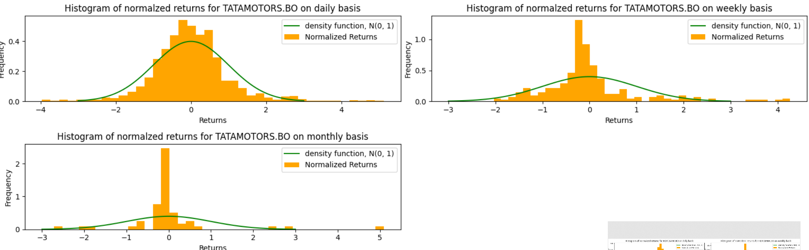 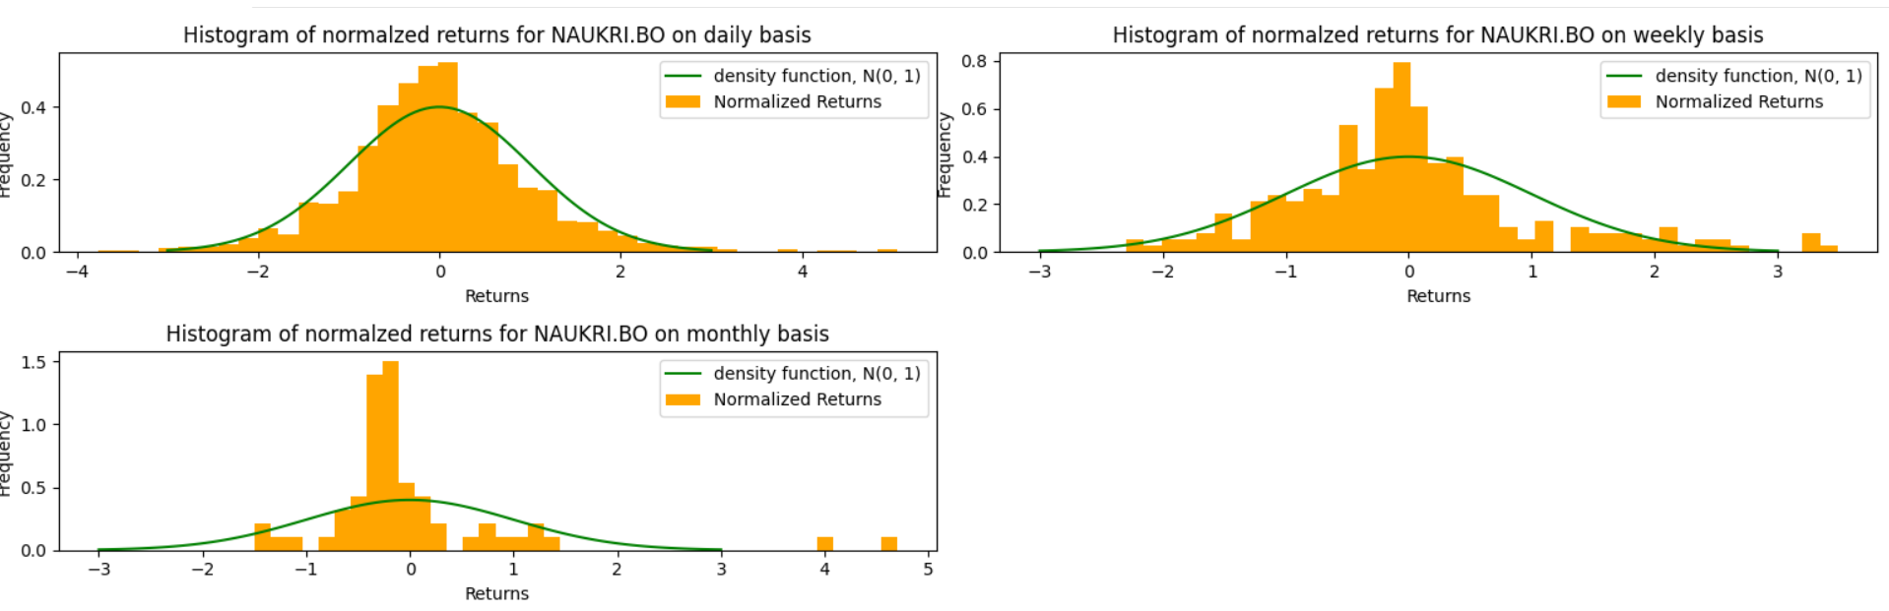 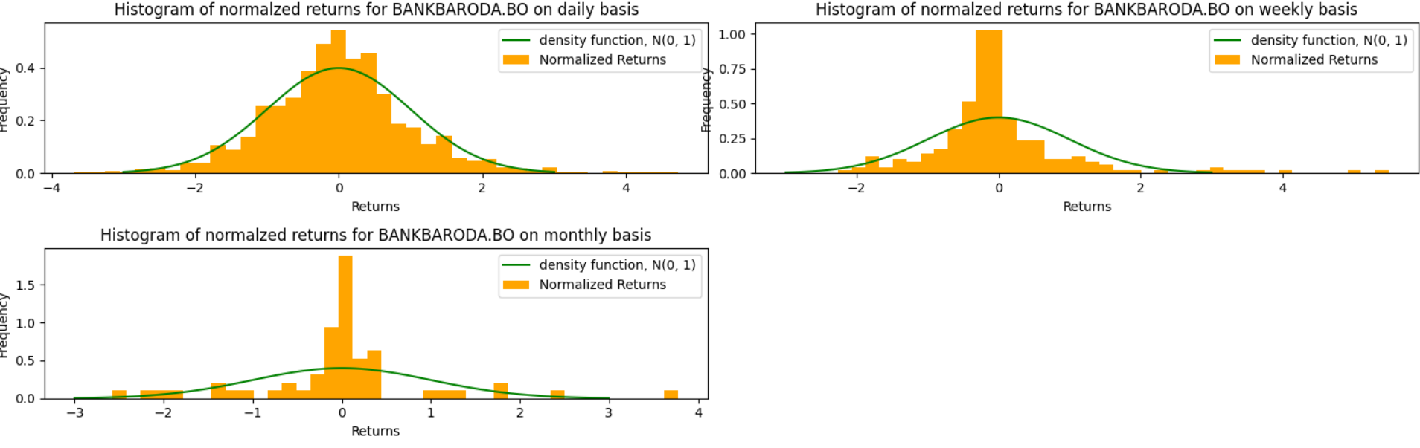

* **boxplots** for bsedata1 are as:

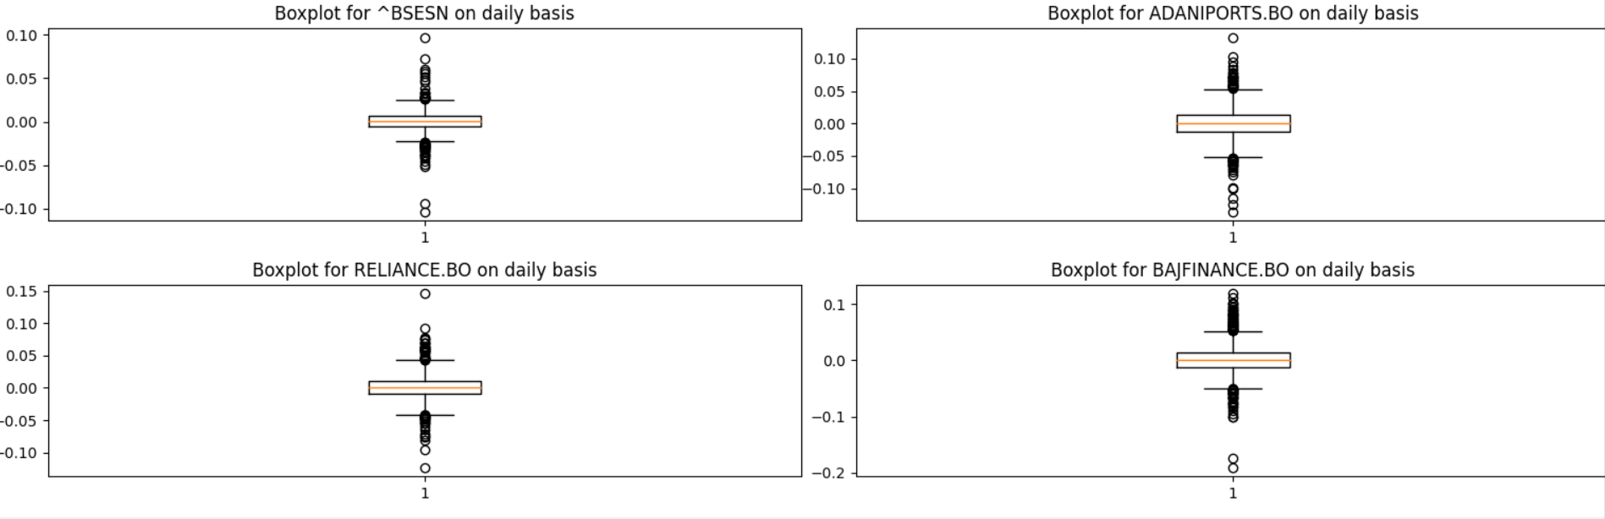 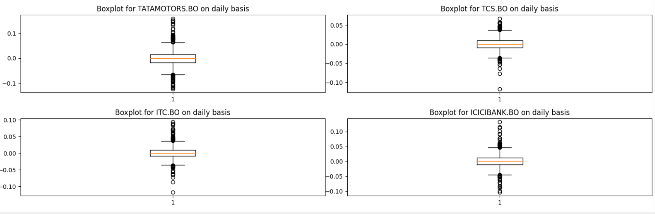 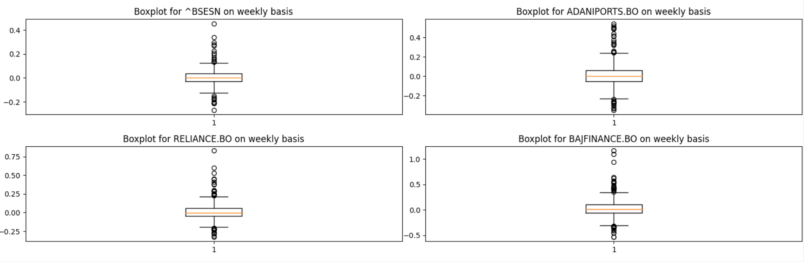 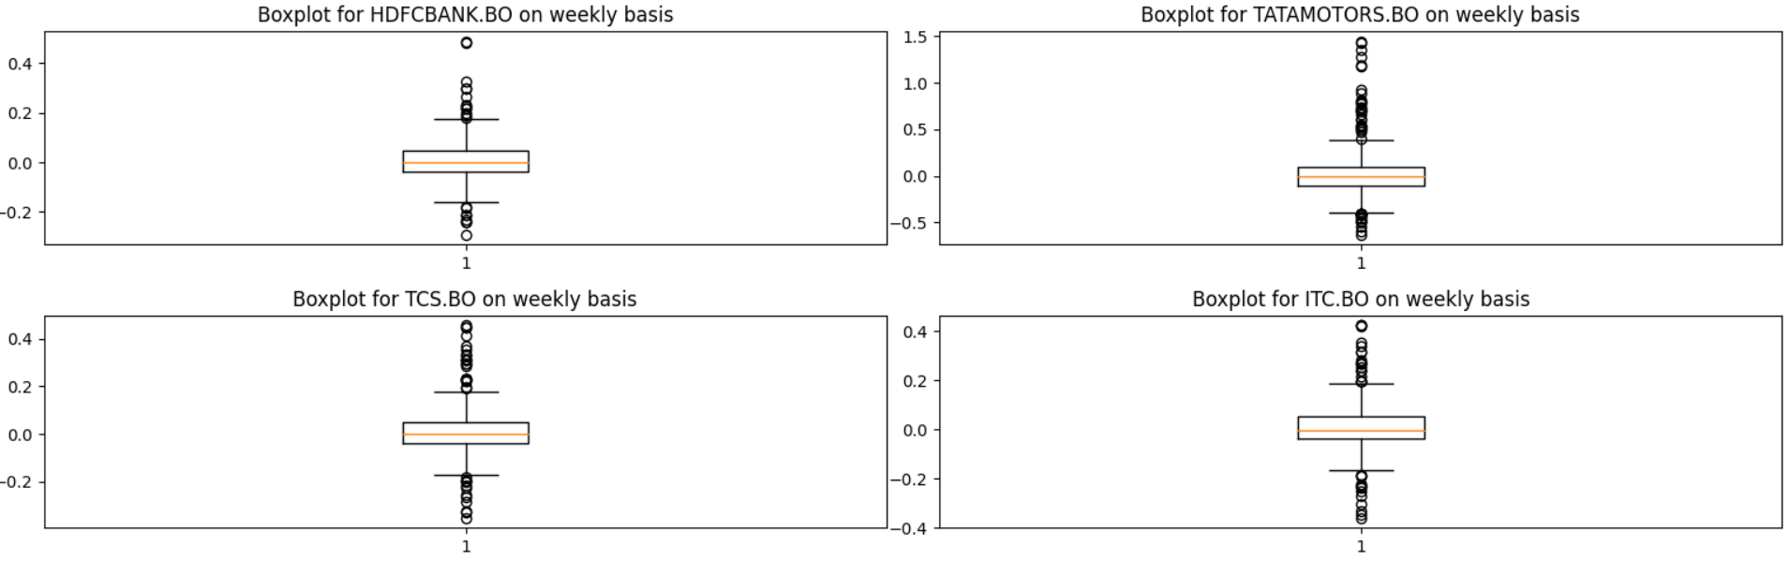 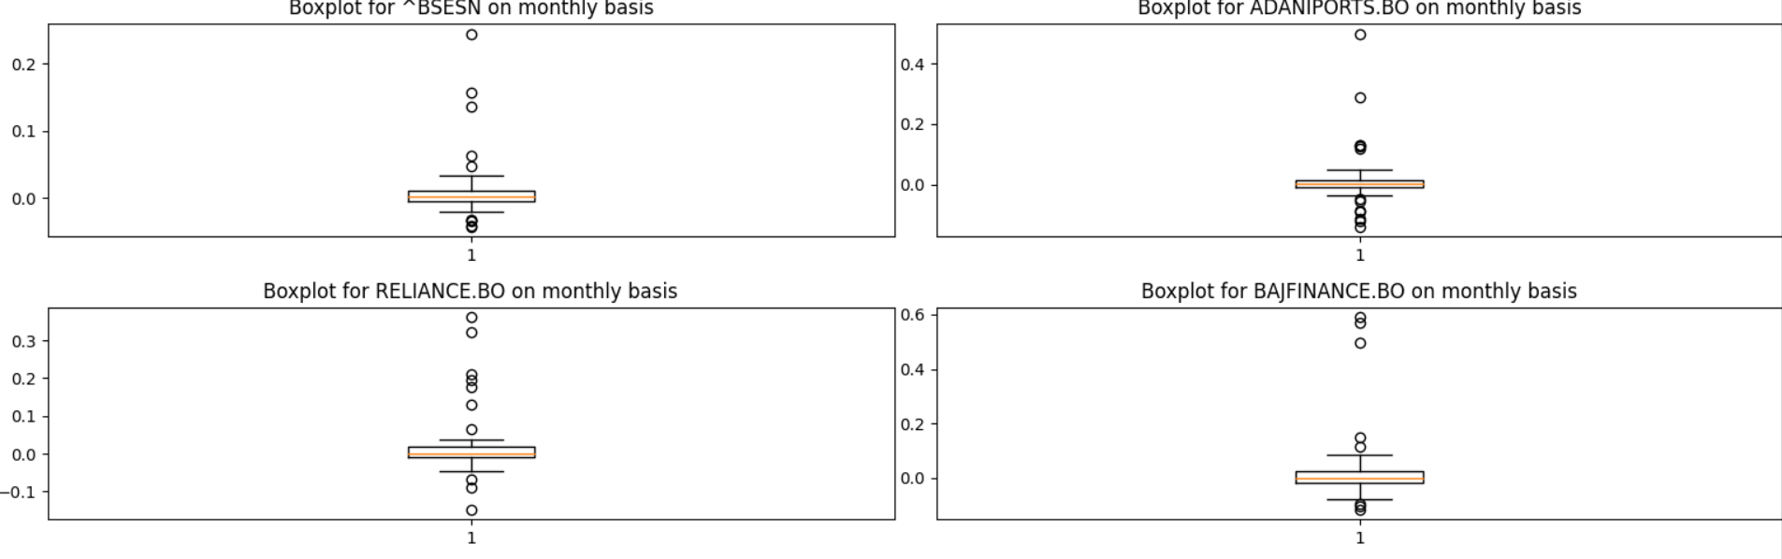 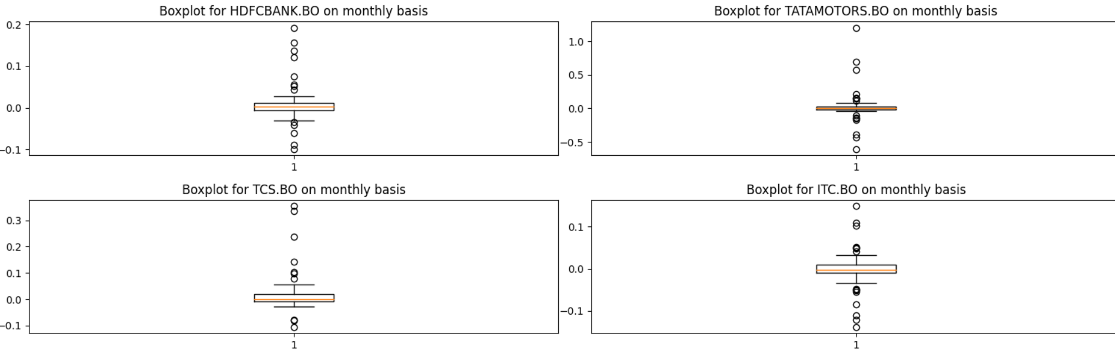

* **quantile-quantile** plots for bsedata1 are as:

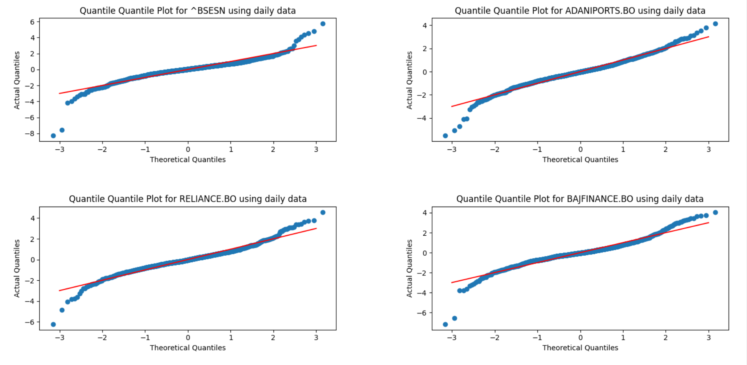 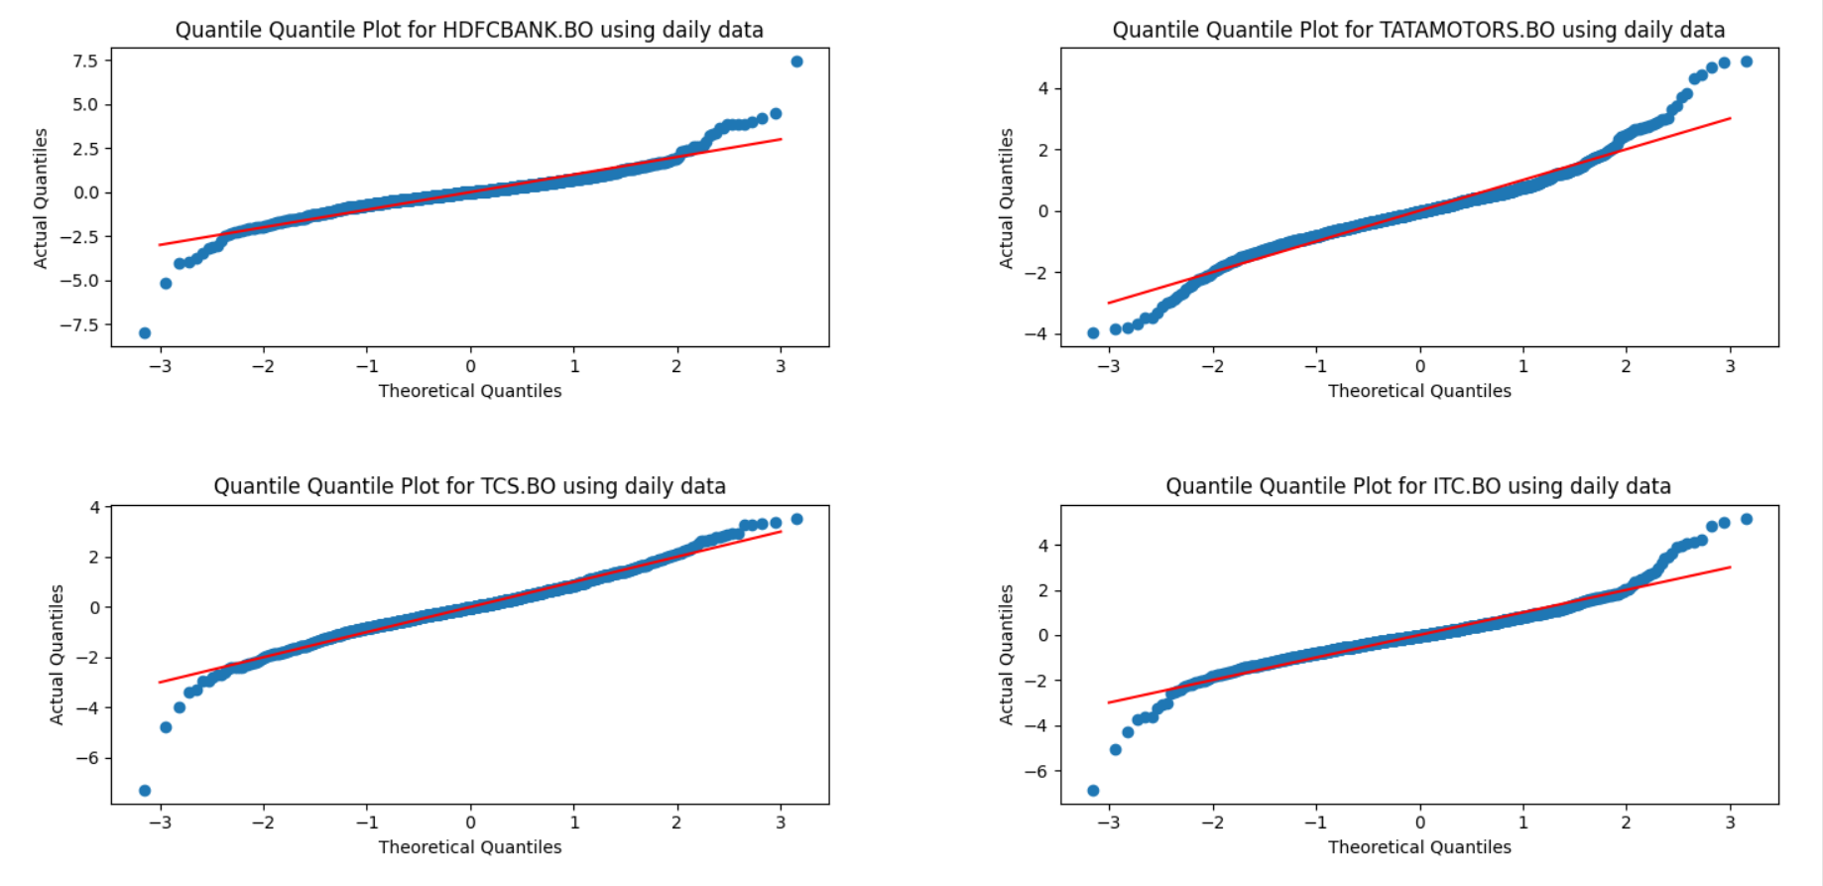 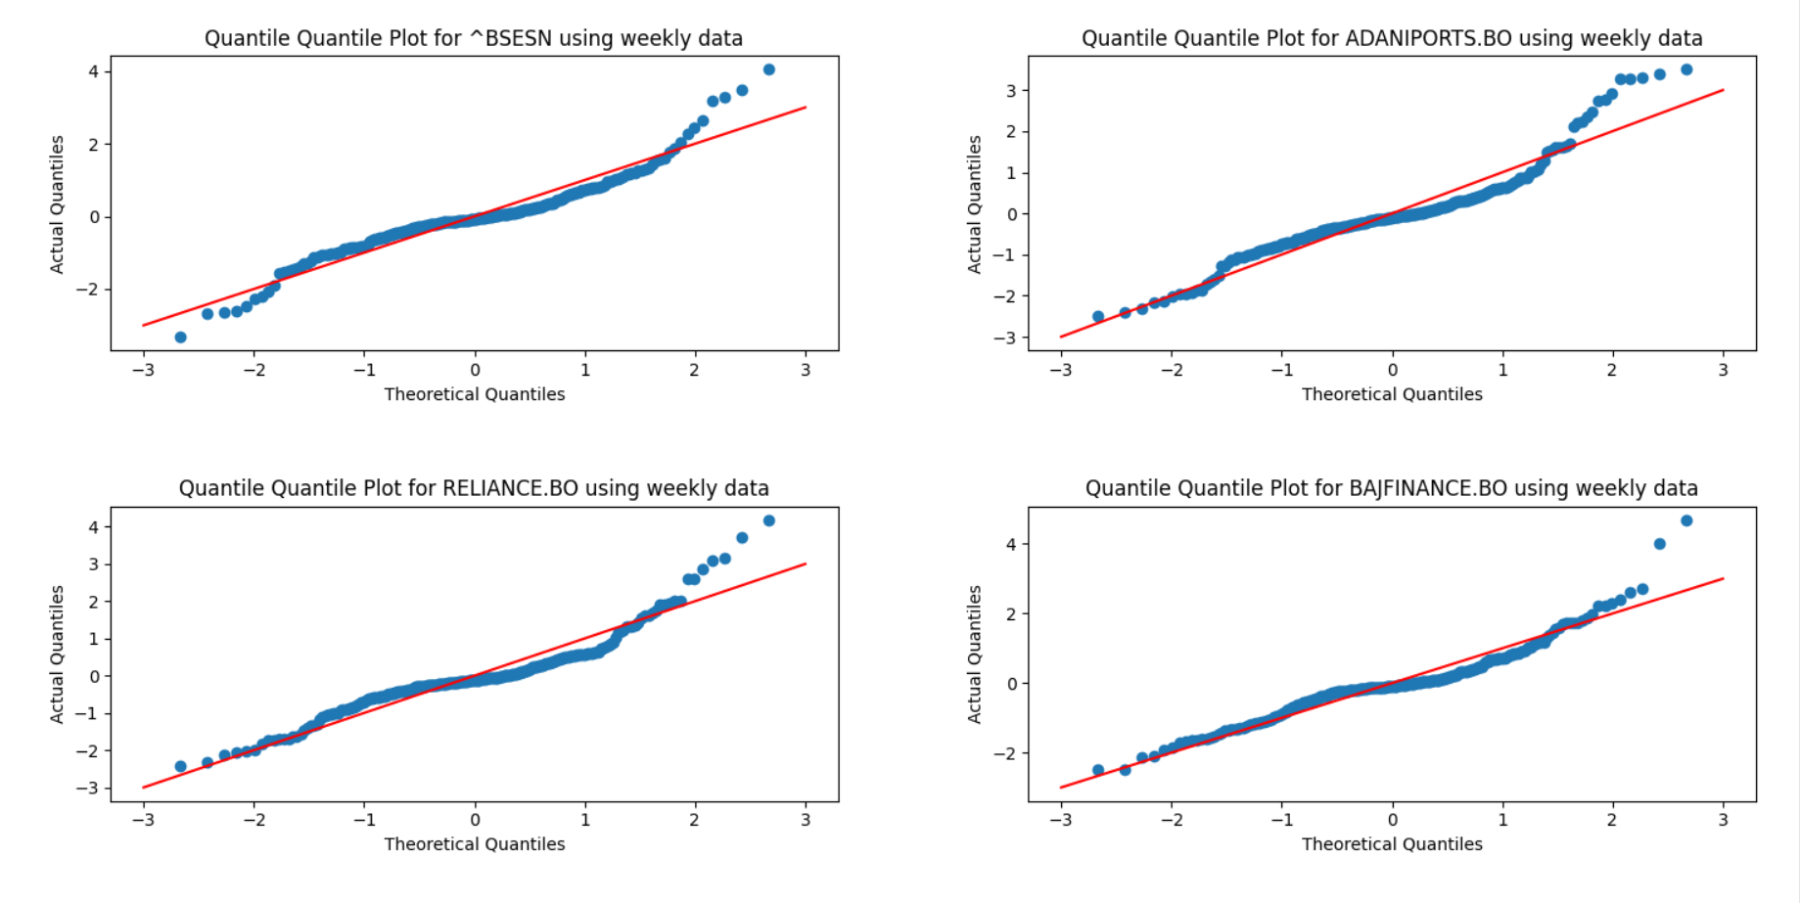 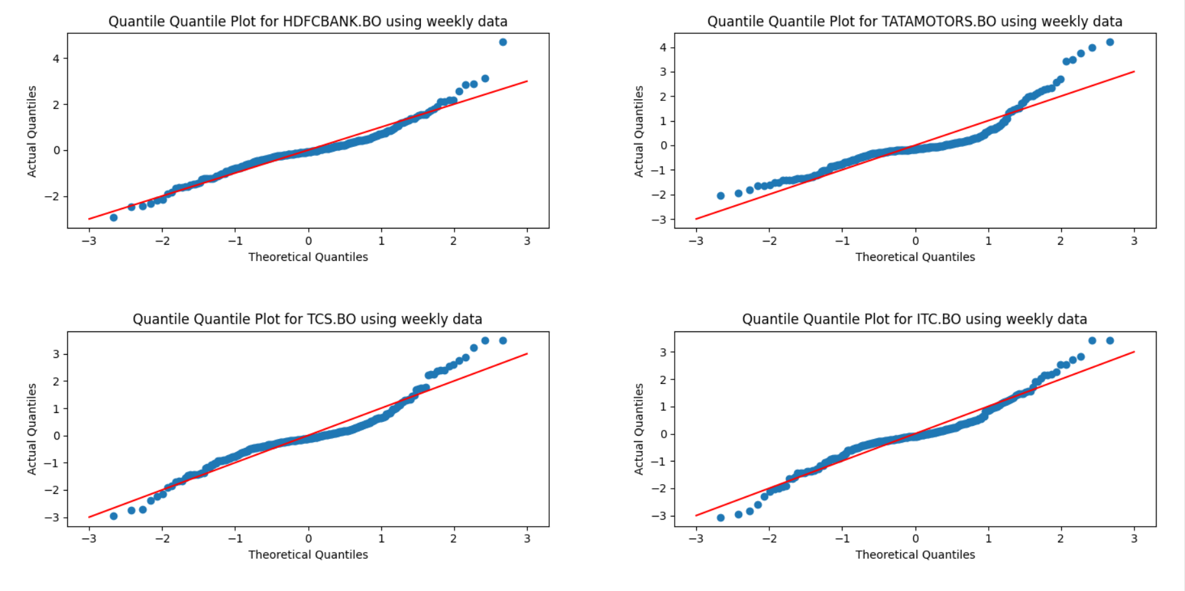 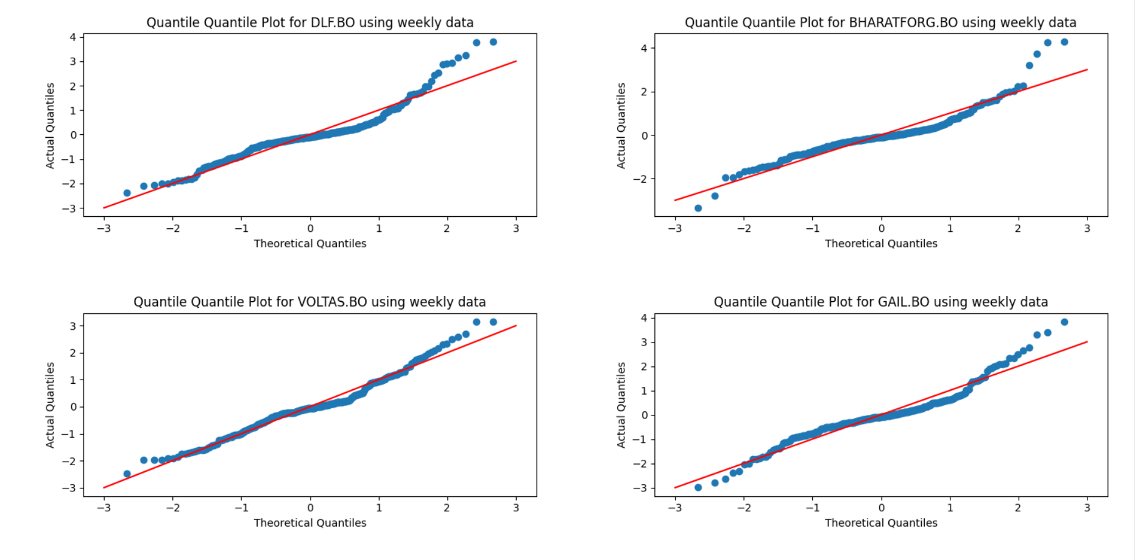 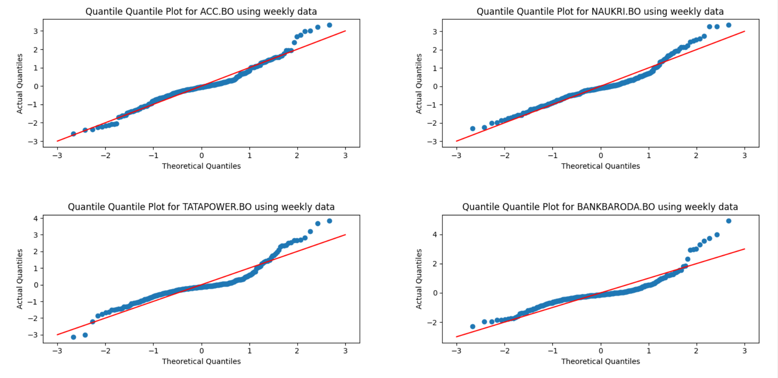

**NSE DATA ANALYSIS**

* Plots (not all) for returns (Ri) for **nsedata1** are:

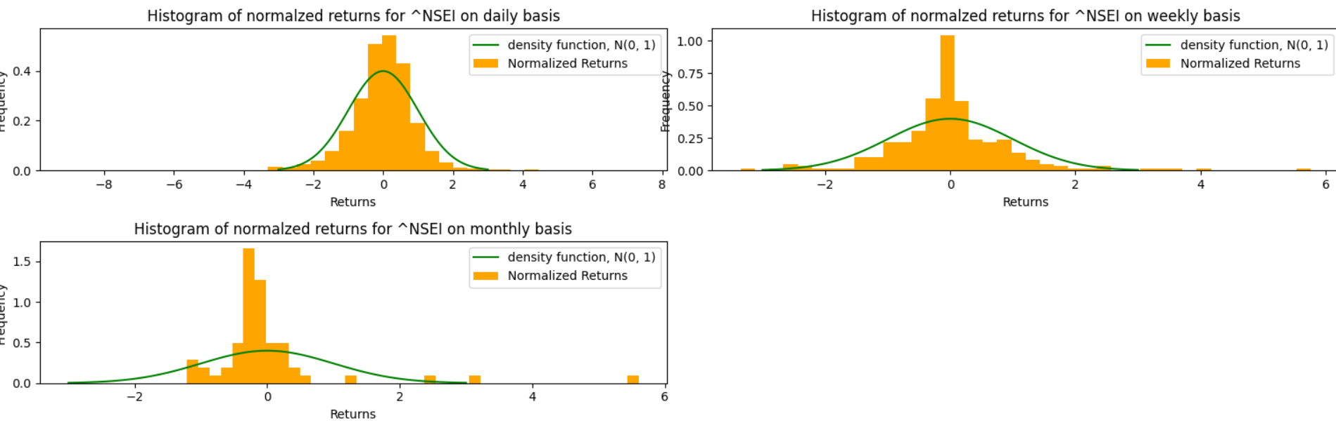 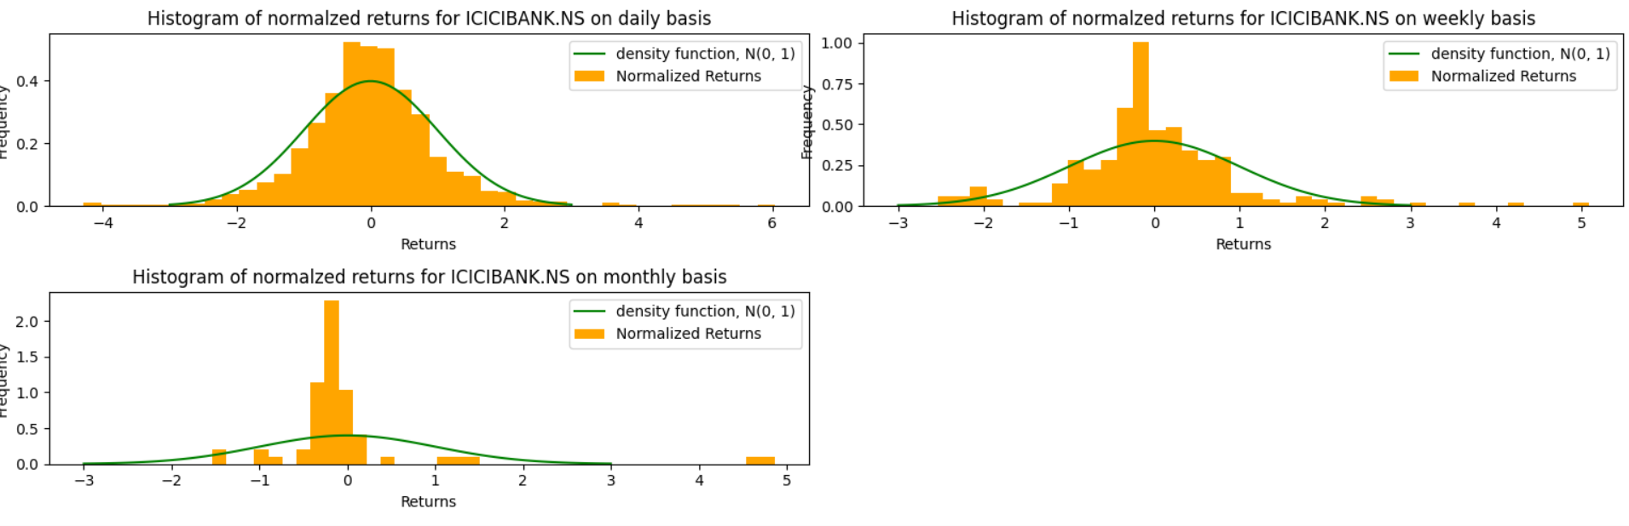 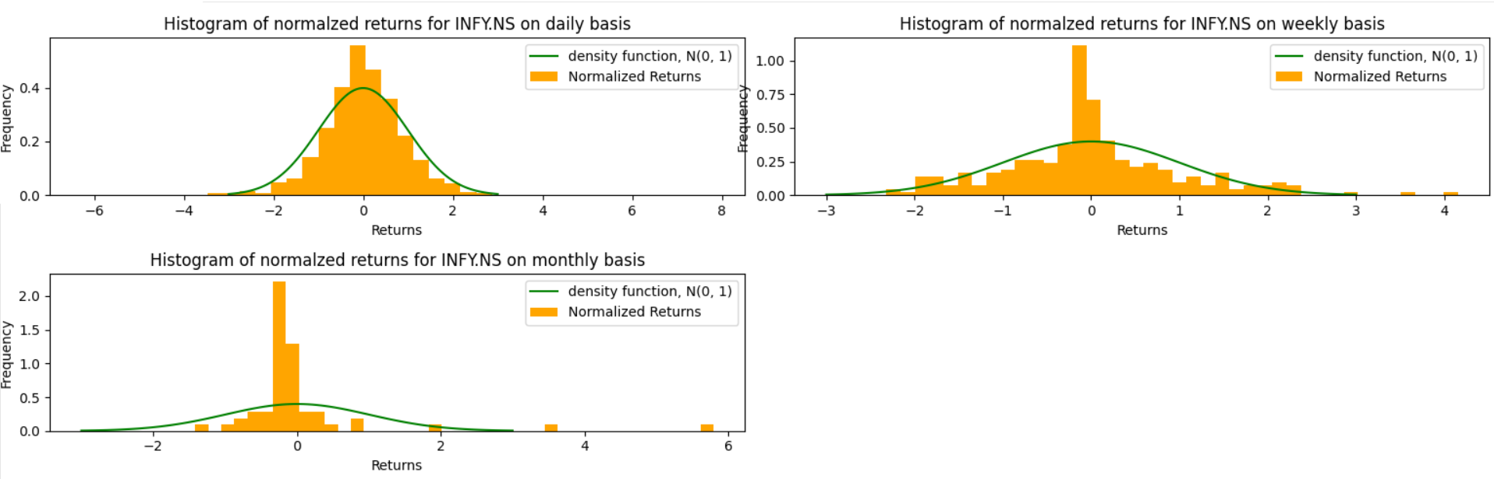 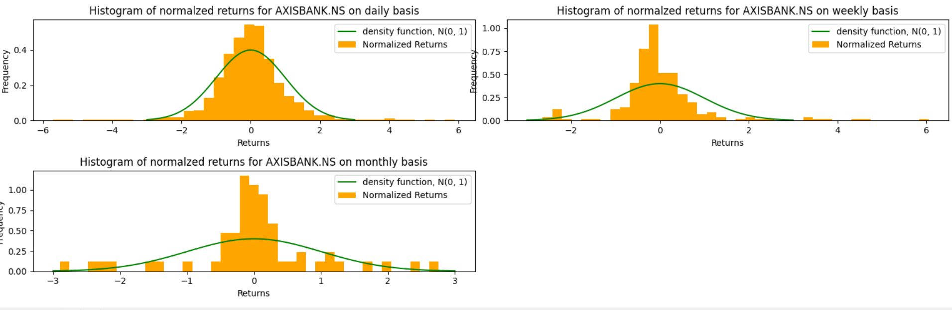 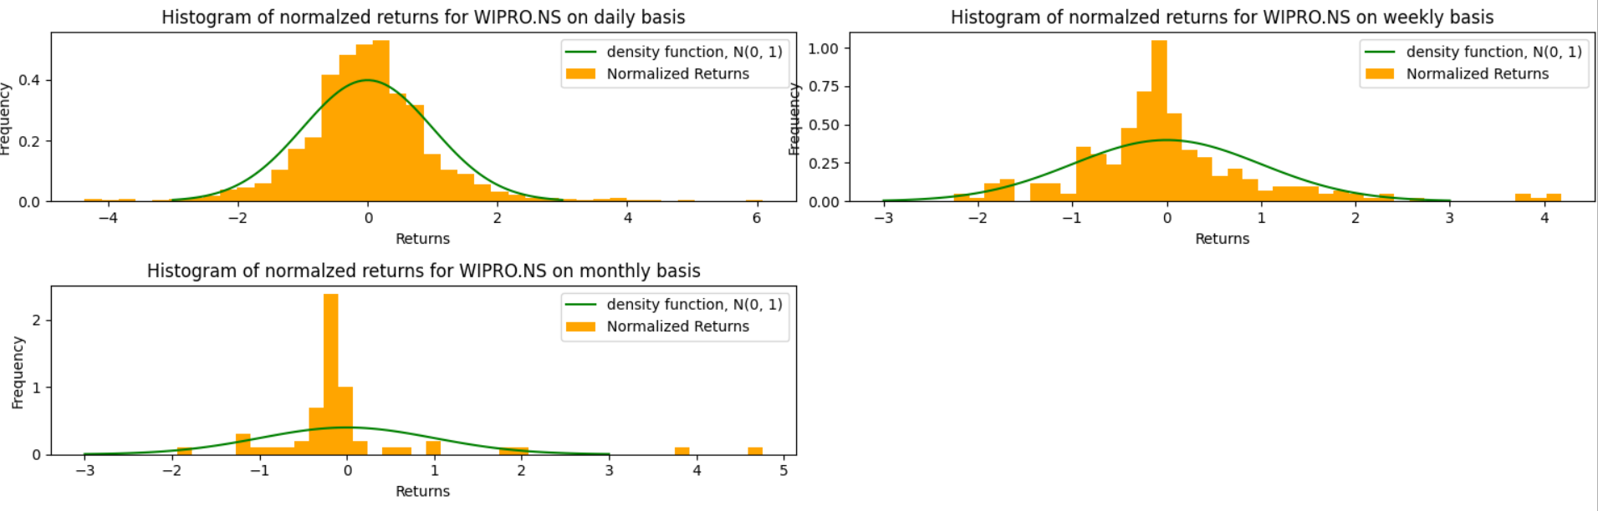 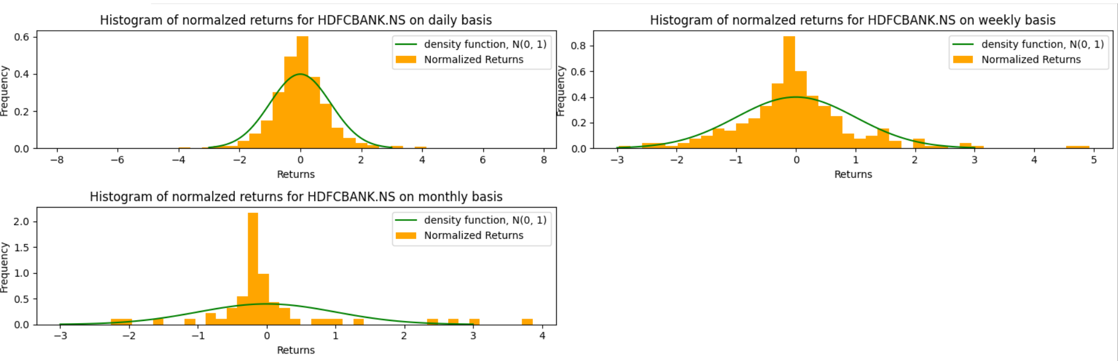 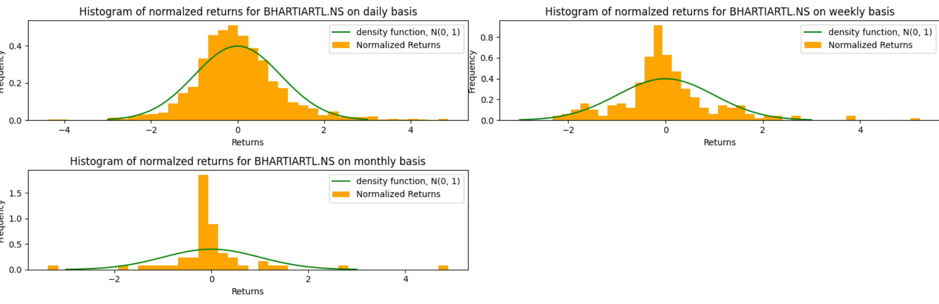 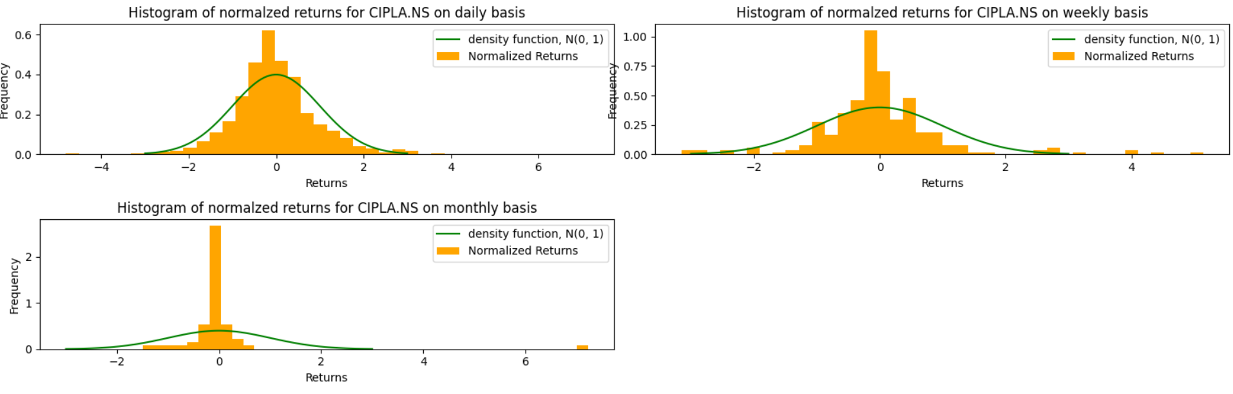

* **boxplots** for nsedata1 are as:

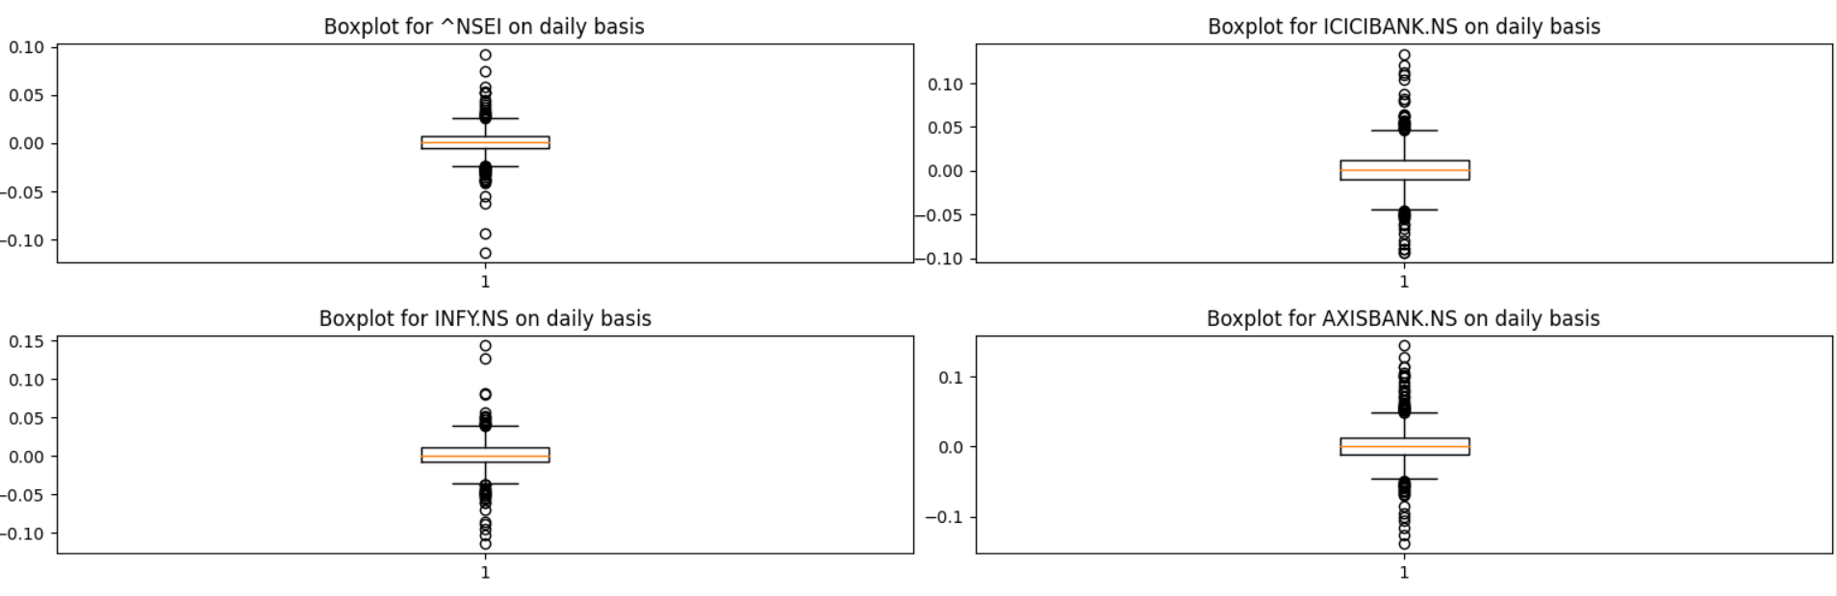

* **quantile-quantile** plots for nsedata1 are as:

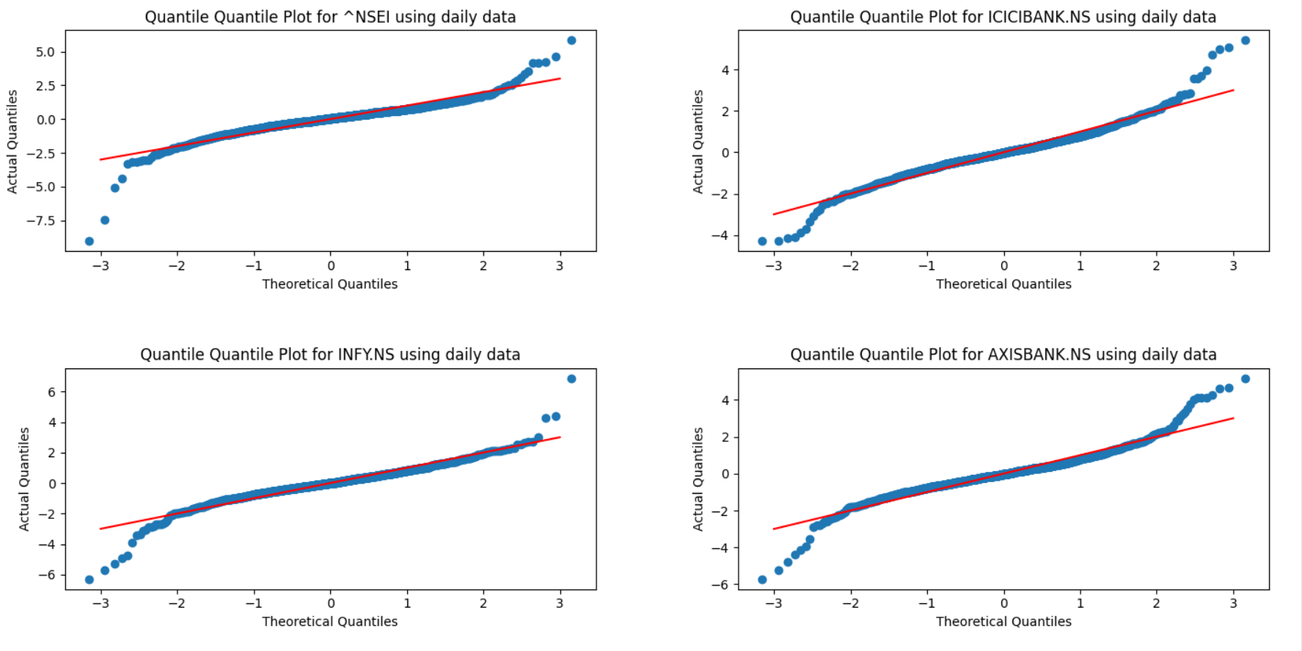 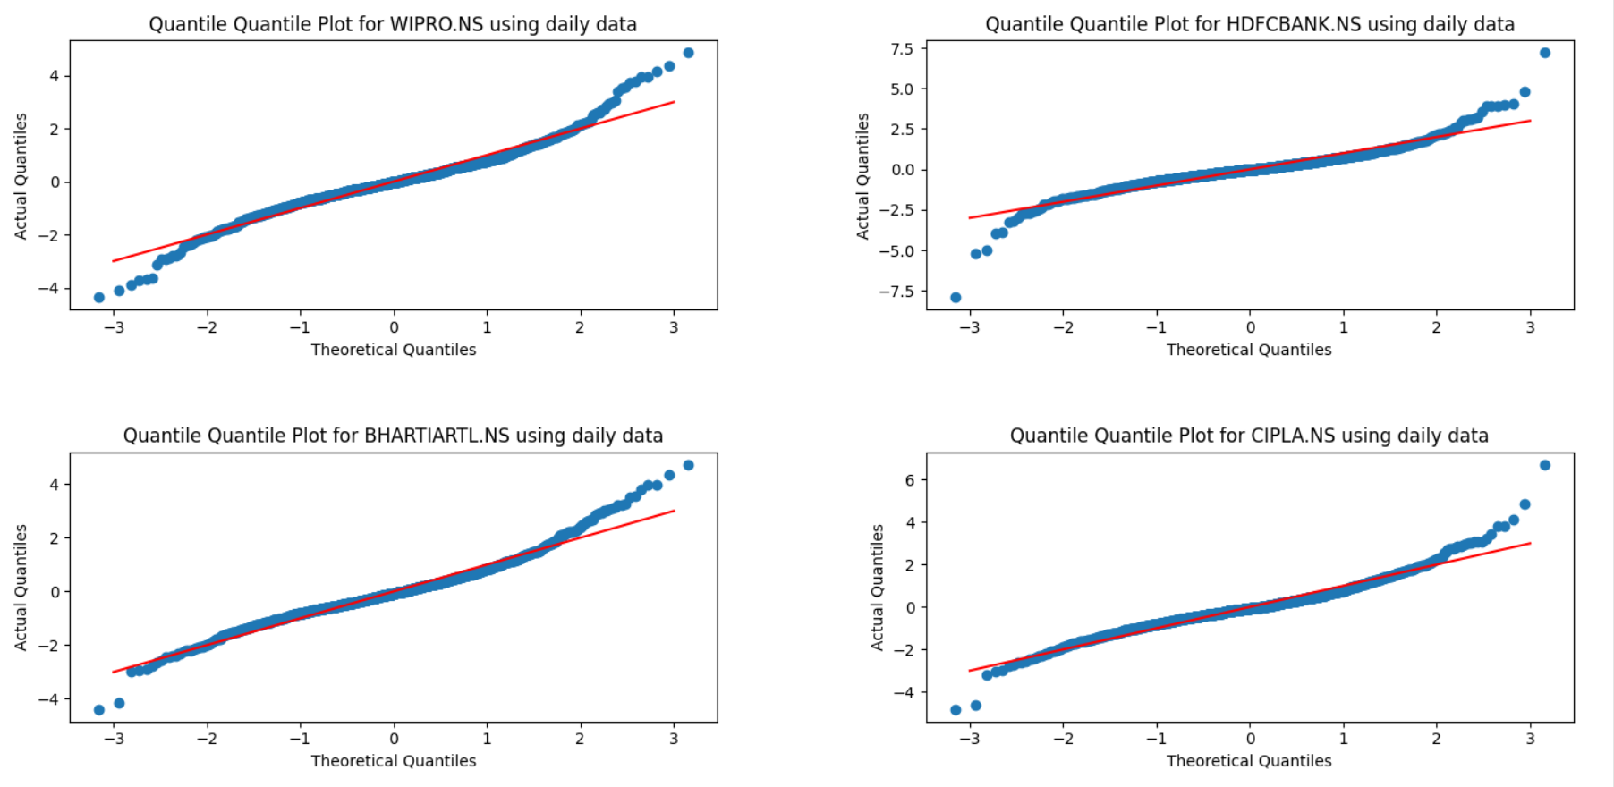 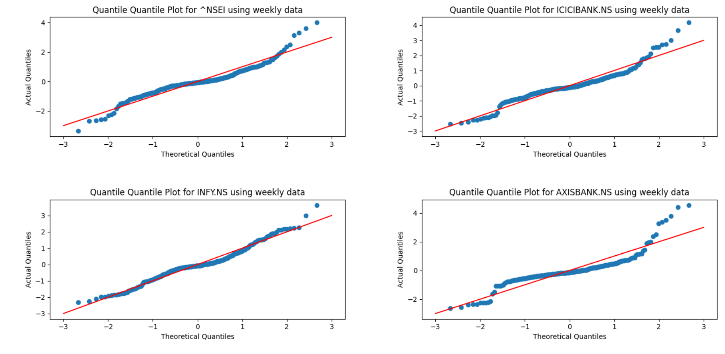 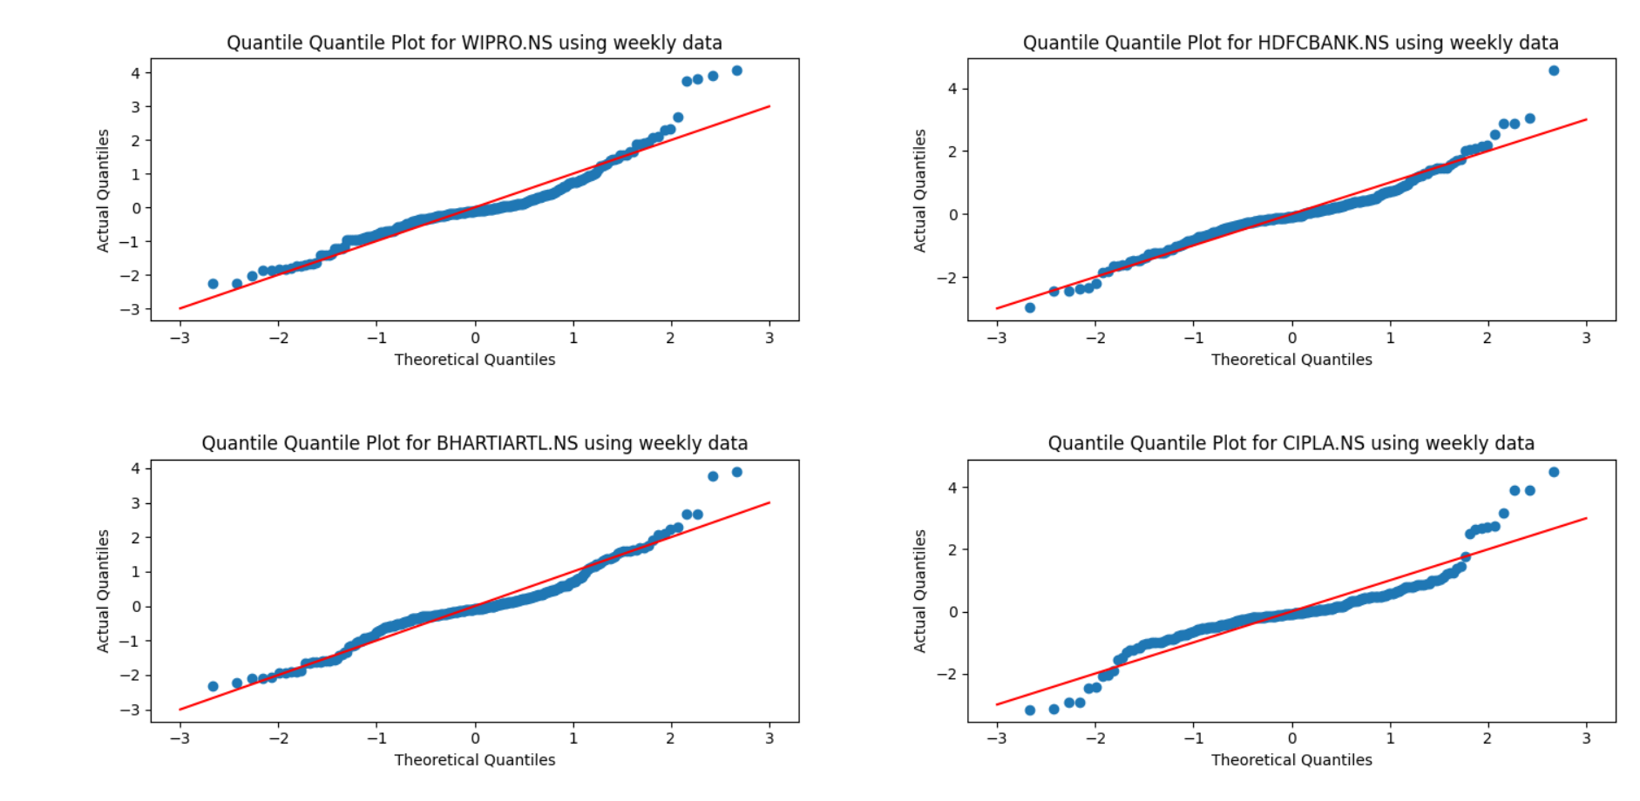

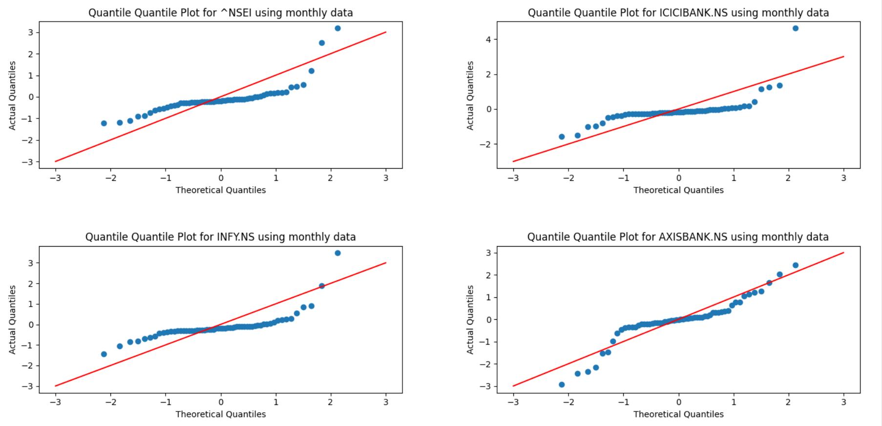 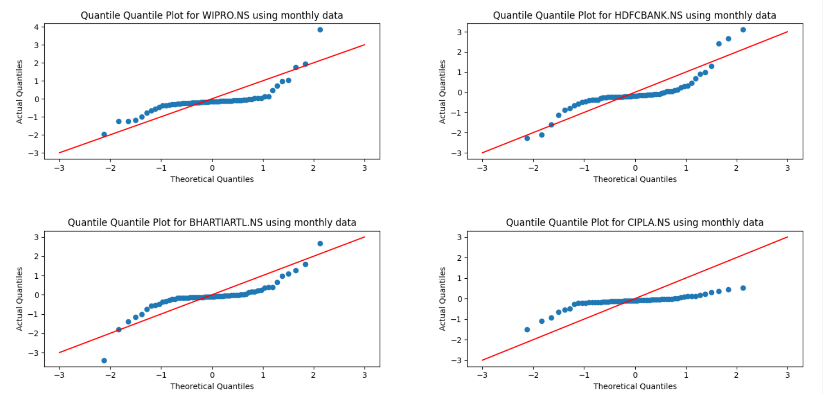

**Observations**

* The N(0,1) distribution provides a rough estimate of the normalized returns.
* Accuracy of estimation improves when returns are computed on a daily basis instead of weekly or monthly.
* Deviations between actual returns and N(0,1) occur due to random fluctuations in the real-world market.
* Naïve Gaussian distribution cannot completely model the market.
* Deviations become more evident when examining the tails of the plots.
* The curve for N(0,1) steeply decreases to zero, but returns on prices do not.
* More deviations occur at the tails, and a more proper model using a mix of different distributions is required to capture those changes.
* Such a behavior is called leptokurtic, meaning high peaks and heavy tails.
* Jump Diffusion model (by Merton) takes these jumps at the tails into account.

**Box plot observations**

* It can be observed that in the majority of cases, the maximum return falls between 1.5 and 2, while the minimum return falls between -1 and -1.5.
* The frequency of values within the first and third quartile decreases uniformly across the range.
* The distribution is symmetric about 0 in some cases while resembling with the Normal distribution with some error.

**Quantile-quantile plot observations**

* It can be observed that the distribution is similar to the Normal distribution because the theoretical and actual quantiles almost overlap on the x=y line. However, this similarity is not as noticeable for large quantiles, such as monthly returns, because the distribution diverges.

**Q3**

Log Returns Data Analysis

**BSE DATA ANALYSIS**

* Plots (not all) for returns (Ri) for **bsedata1** are:

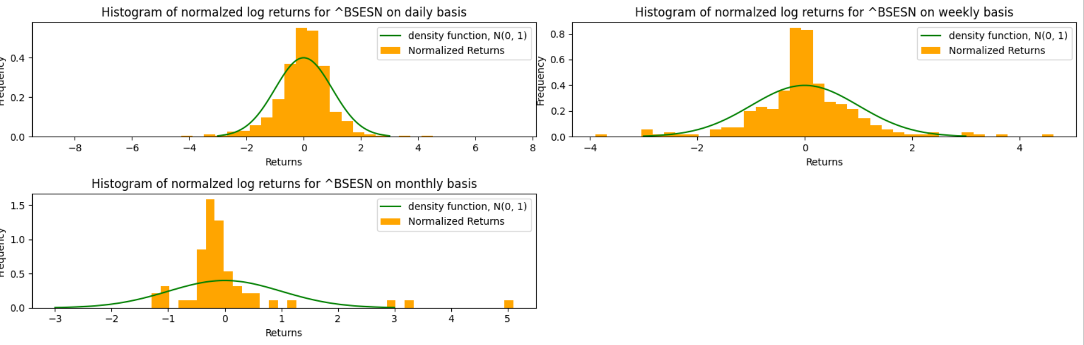 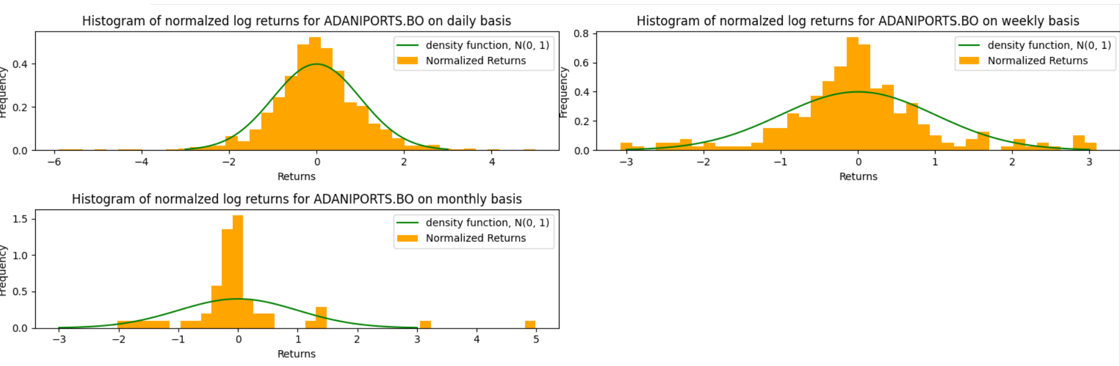 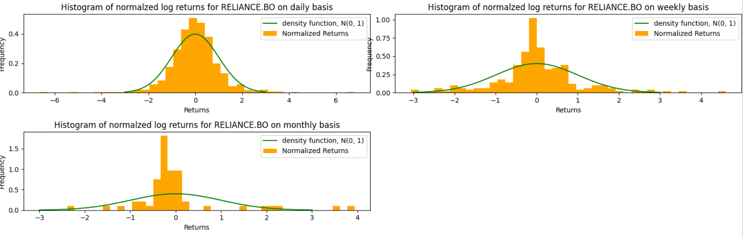 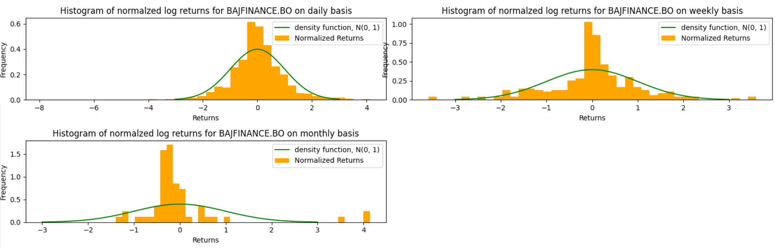

* **boxplots** for bsedata1 are as:

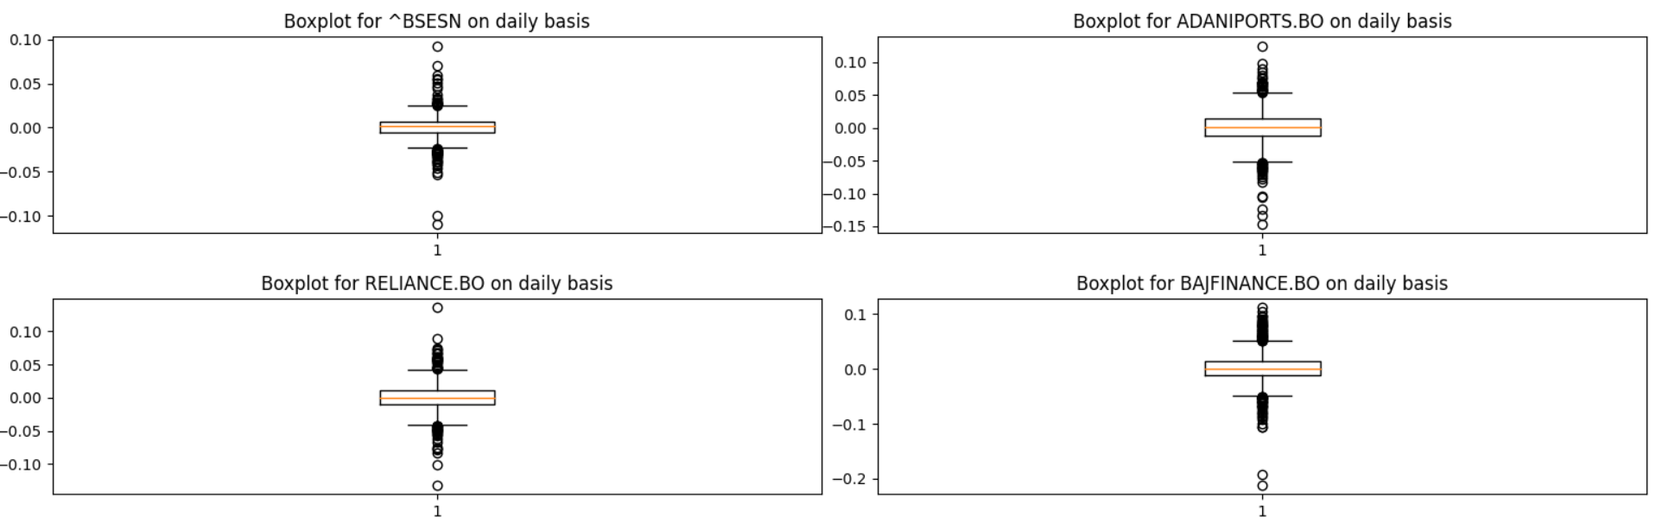

* **quantile-quantile** plots for bsedata1 are as:

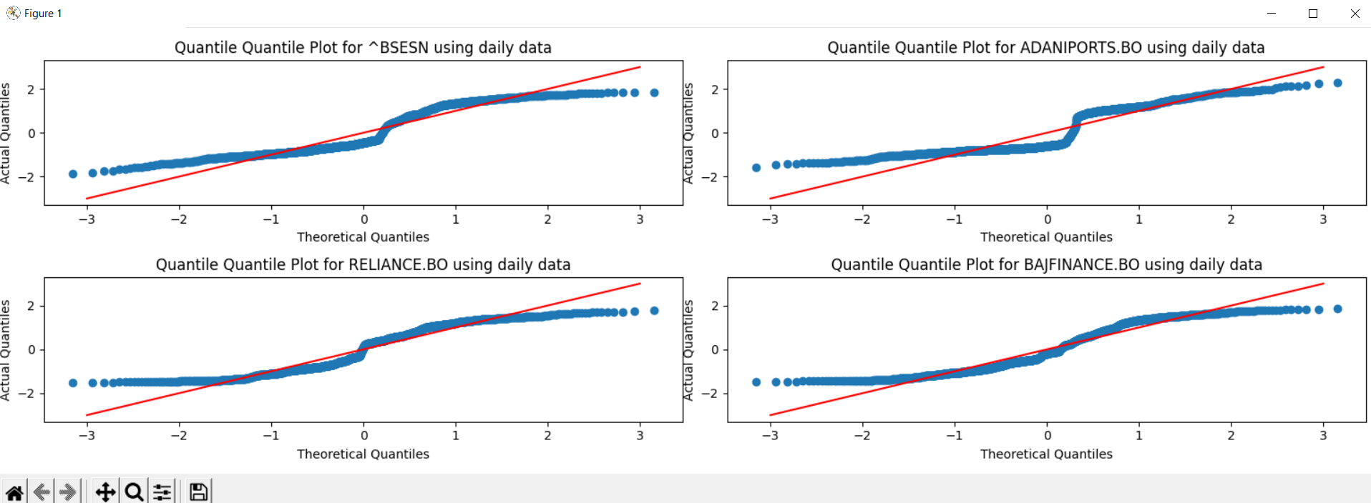

**NSE DATA ANALYSIS**

* Plots (not all) for log returns (Ri) for **nsedata1** are:

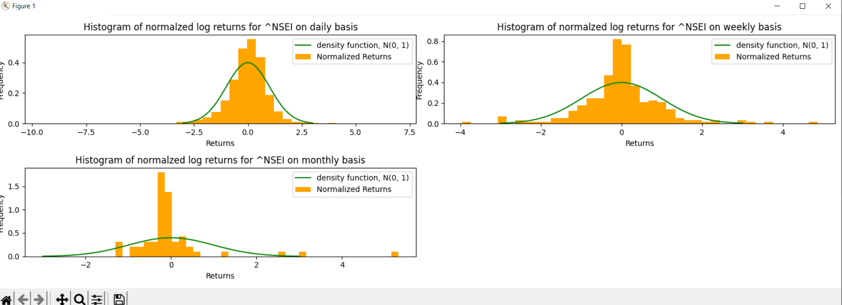 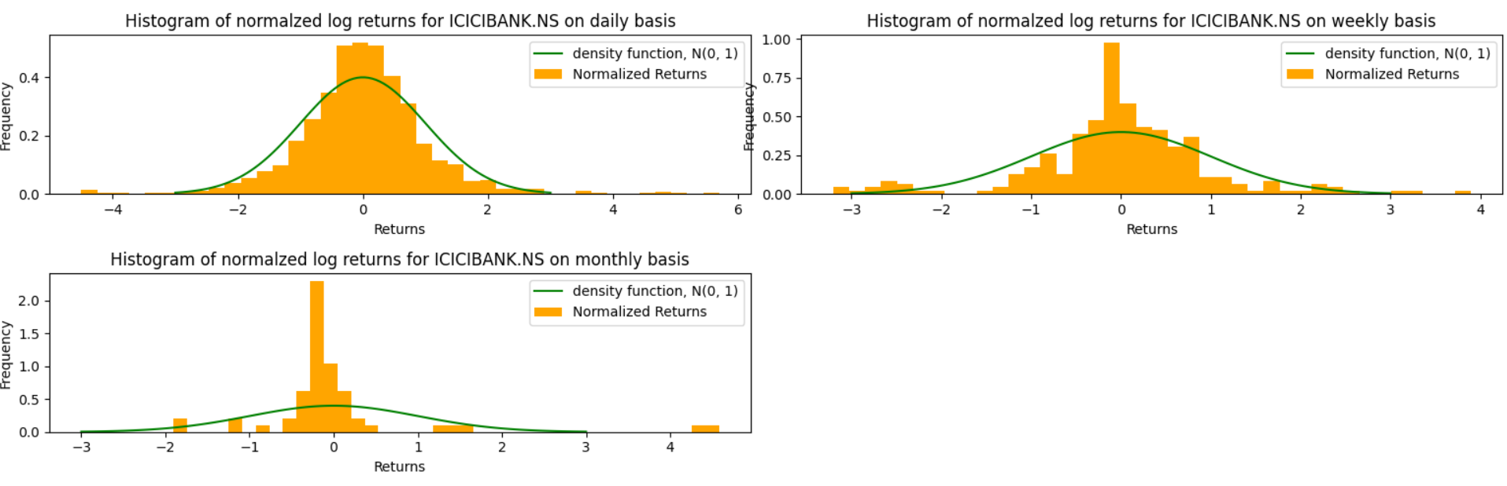 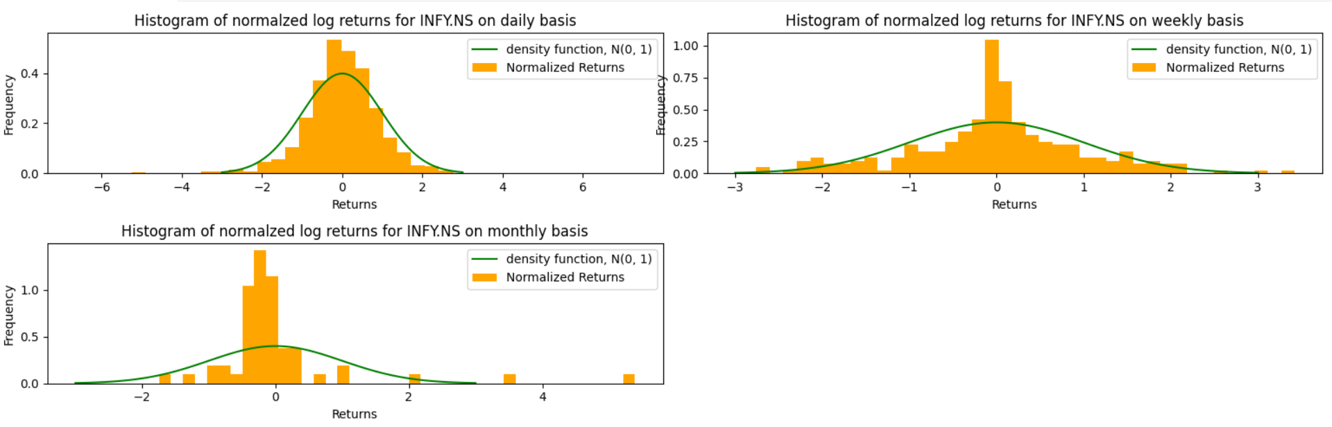 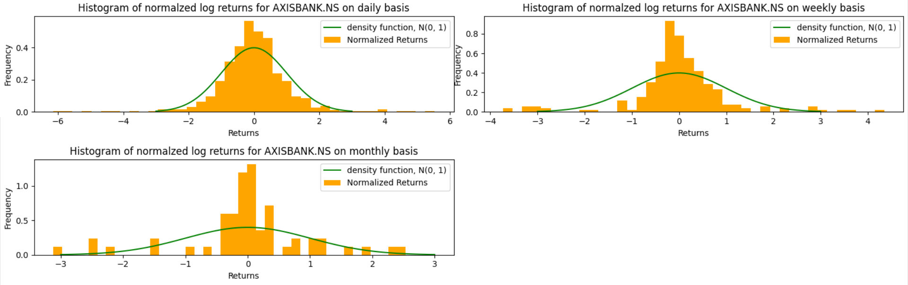

* **boxplots** for nsedata1 are as:

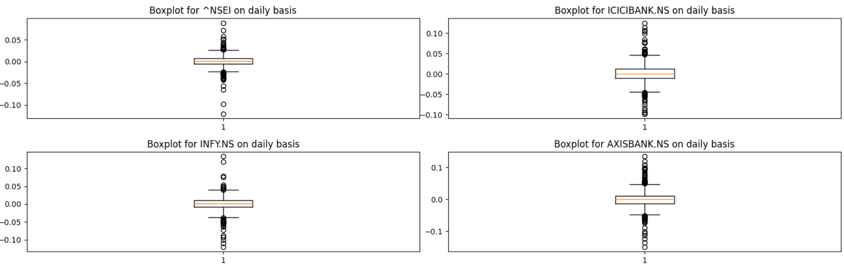

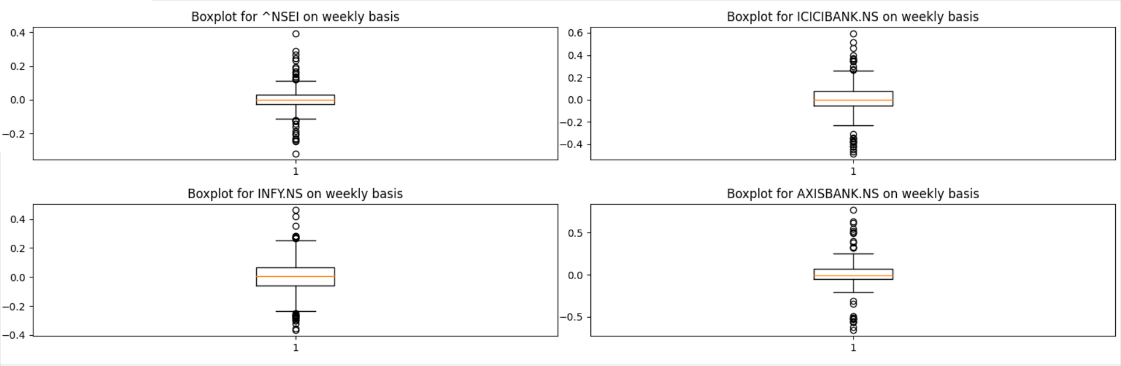 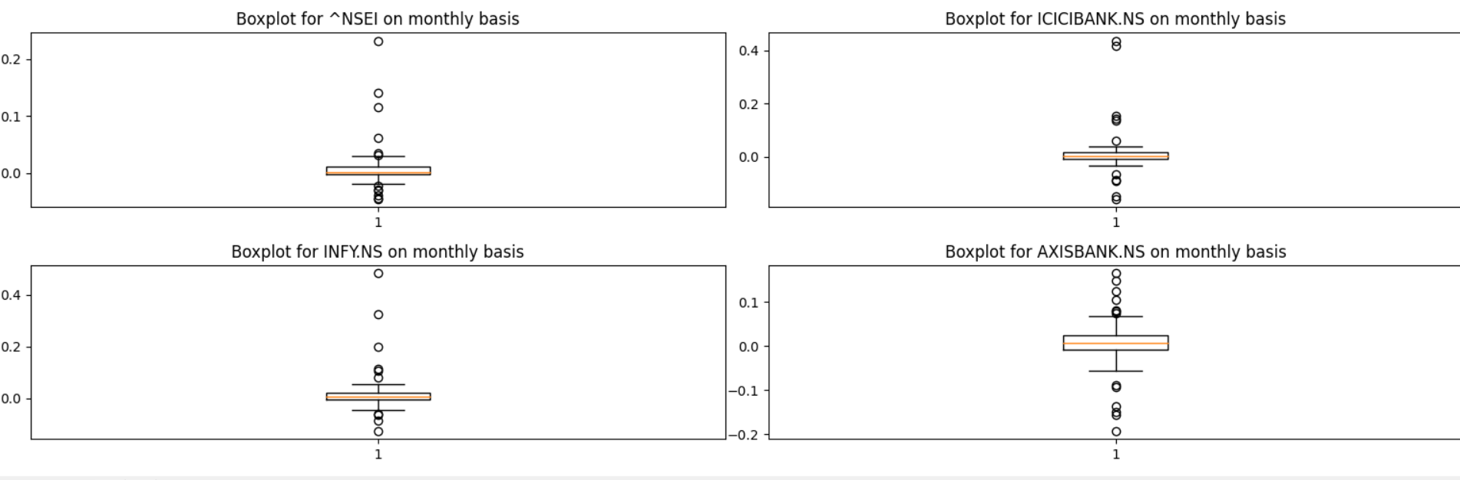

* **quantile-quantile** plots for bsedata1 are as:

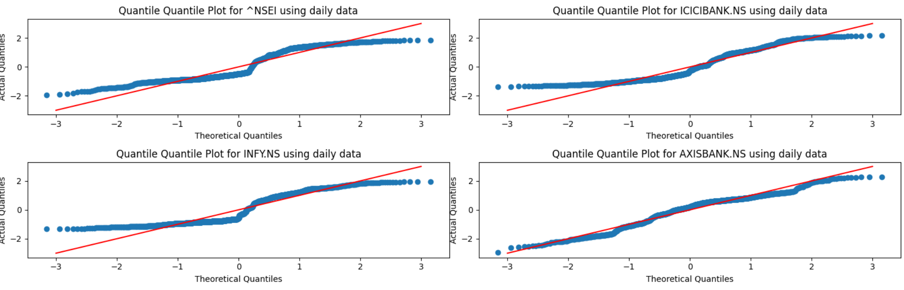 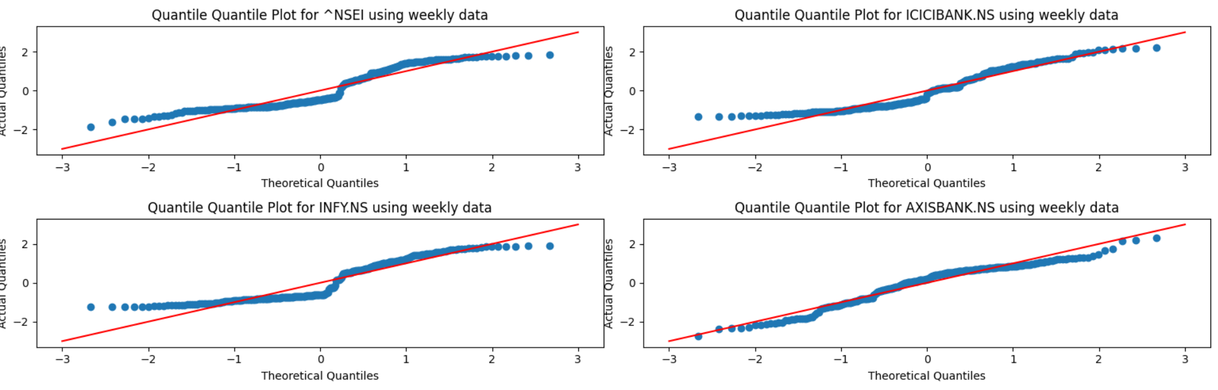 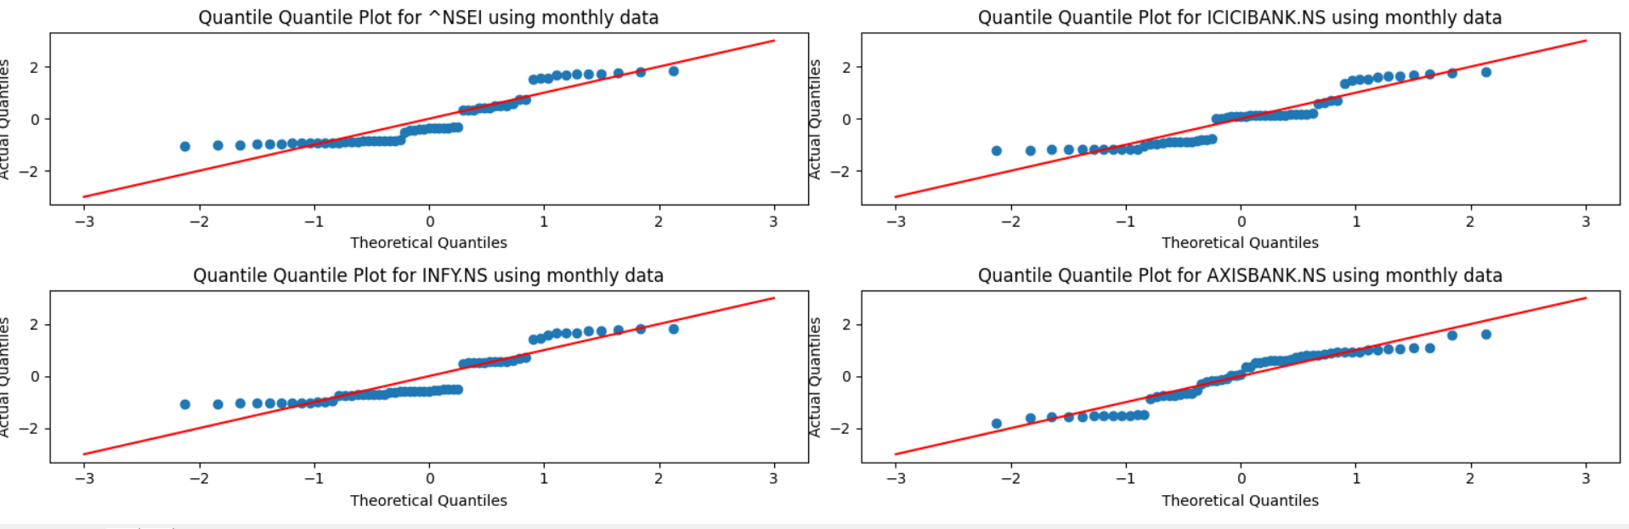

**Observation**

* The observations are exact similar to 2nd question, but here we see little less deviation between the N(0,1) curve the histogram plotted.

**Q 4 and Q5**

Geometric Brownian motion is a suitable mathematical model for representing the behavior of stock prices as a stochastic process. The stock price at time t_(i+1) can be described by the equation

$$S\left(t_{i+1}\right)=S\left(t_{i}\right)\exp\left(\left(μ-0.5σ^{2}\right)\left(t_{i+1}-t_{i}\right)+σ\sqrt{t_{i+1}-t_{i}}Z_{i+1}\right)$$

, where μ and σ^2 are determined by solving the following equations:

$$\begin{matrix}μ-\frac{σ^{2}}{2}=\frac{1}{n}\sum_{1}^{n}{ } u_{i}=E(u) \\ σ^{2}=\frac{1}{n-1}\sum_{1}^{n}{ } {\left(u_{i}-E(u)\right)}^{2} \\ u_{i}=ln⁡\left(\frac{s_{i}}{s_{i-1}}\right)\end{matrix}$$

Here, u_i is the log return of day i, s_i and s_(i-1) are the adjacent closing stock prices of day i-1 and day i, respectively. Additionally, Z_1,Z_2,…,Z_n are independent N(0,1) variables.

**BSE DATA ANALYSIS**

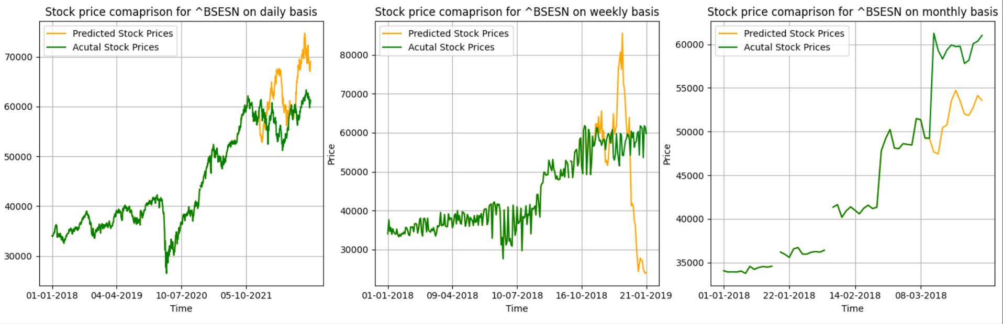 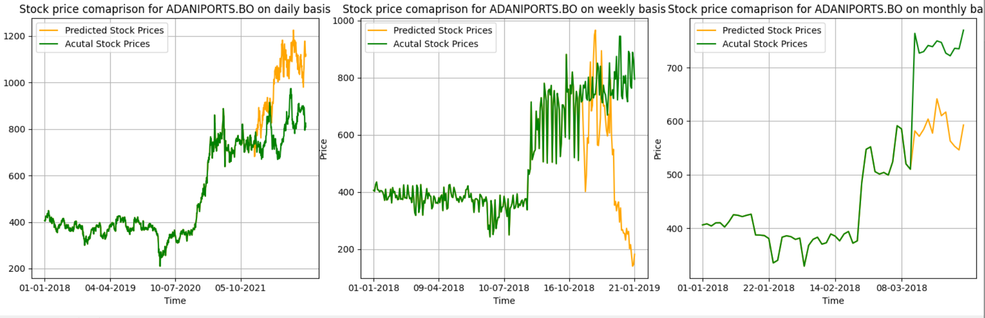 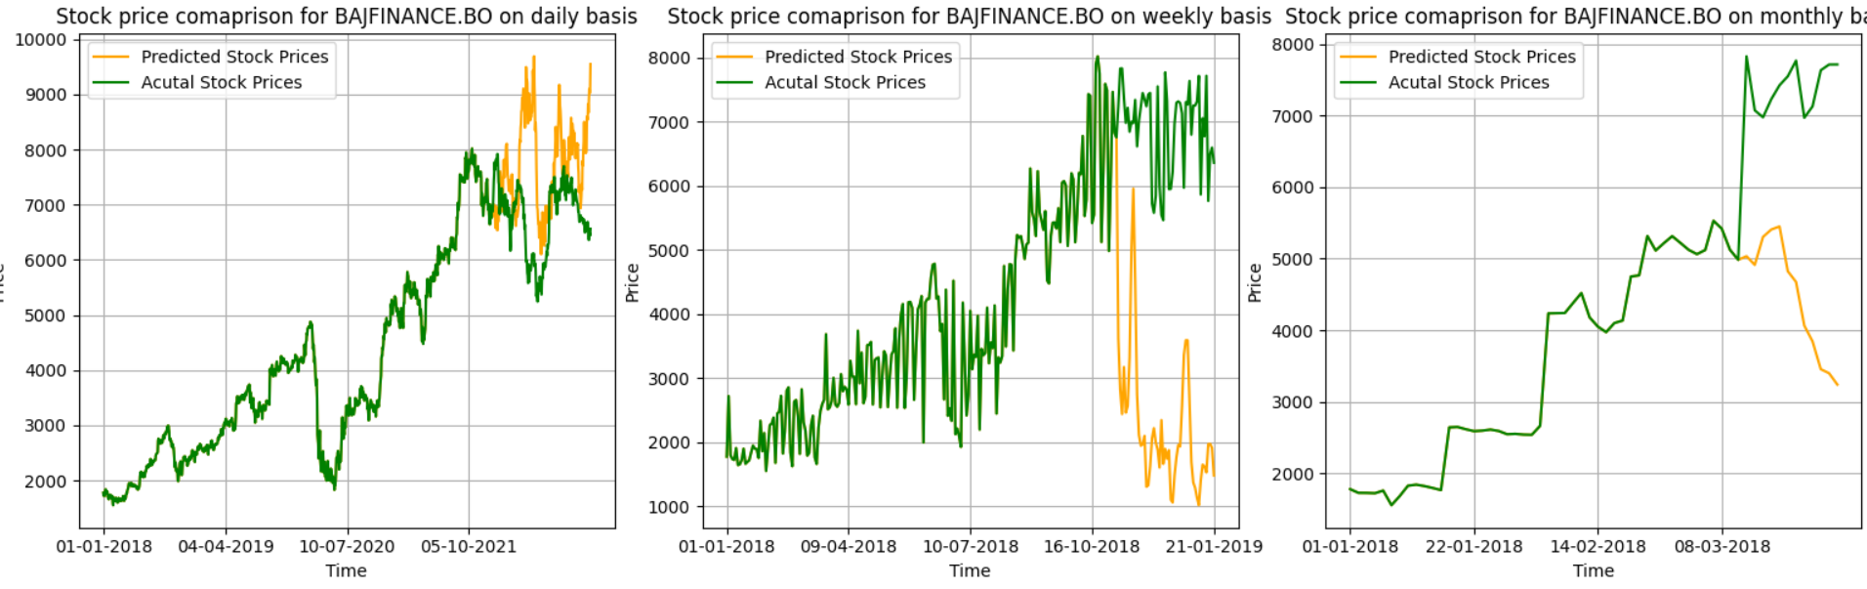 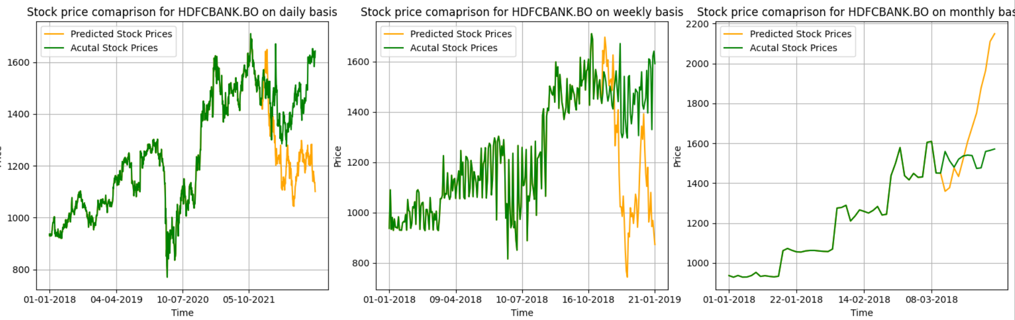

**NSE DATA ANALYSIS**

 